Opens This Friday, Dec. 4
Schenectady Civic Players proudly present….
Louisa May Alcott’s

(The Musical)

Book by Alan Knee, Music by Jason Howland, Lyrics by Mindi Dickstein
Directed by Duncan Morrison Musical direction by Val Lord
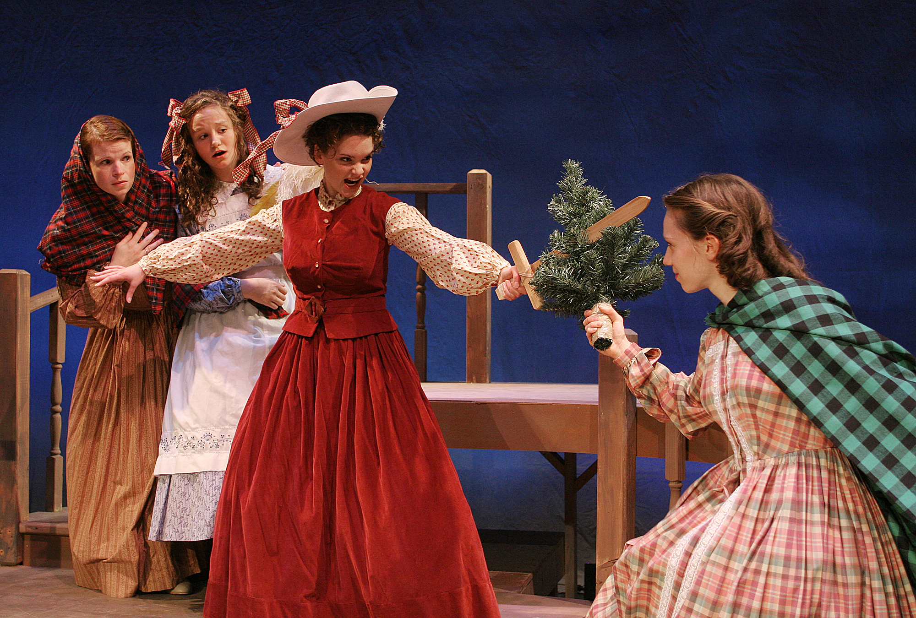
The March Women ( l to r): Allison Sharpley (Beth), Cabrina McGinn (Jo),
Cathryn Salamone ( Jo), and Claudia DeMartino (Meg).

December 4 – 6 & December 9 – 13
(Fridays & Saturdays at 8 pm, Wednesday & Thursday 7:30 pm, Sunday matinees only at 2:30 pm)

Based on Louisa May Alcott’s classic 1869 semi-autobiographical novel, Little Women (The Musical) follows the adventures of Jo, Meg, Beth, and Amy March as they grow up in Civil War America. The beloved story of the March sisters is brought to life in this exhilarating musical, filled with glorious music and heart. It is a complete theatrical experience, promising a performance filled with laughter, a lifting of the spirit, and, perhaps, even a few tears. What a treat for the holiday season!
The cast features: Cathryn Salamone (Jo March), Adrien Gleason (Professor Bhaer), Allison Sharpley (Beth March), Cabrina McGinn (Amy March), Claudia DeMartino (Meg March), Kimberly Waldin (Marmee March), David Marcil (Mr. Laurence), Anthony Rontondaro (Laurie Laurence), Debbie May (Aunt March), and Suzanne Talarico (Mrs. Kirk).
at the Schenectady Civic Playhouse
12 South Church St. in Schenectady’s historic Stockade District
FOR TICKETS ($15), Call The Playhouse (518) 382-2081
Or order on-line 24 hrs. a day at www.civicplayers.org

