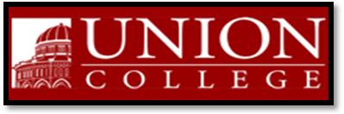
Union College Music Department
Presents

ENSEMBLE PASTOURELLE

Sunday, May 2, 2010 at 3:00 PM
Memorial Chapel, Union College
807 Union Street, Schenectady, New York 12308

Concert Free and Open to Public
Featuring
Corine Salon, Soprano Michael Clement, Piano
Susan Martula, Clarinet Leah Kidwell-Fernandes, Harp
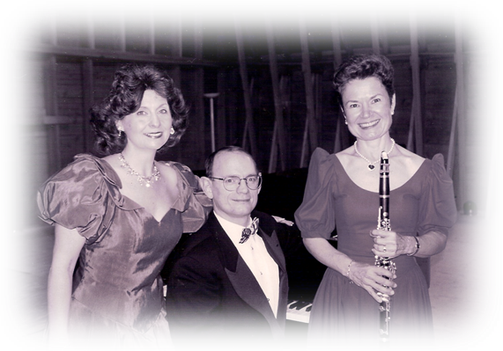
Performing Music by:
Spohr, Ravel, Grandjany, Debussy, Canteloube, Rachmaninoff, Salzedo, Rodrigo, Hilary Tann

For Information Call: 388-6785 or the Music Hotline 388-6201
For reception afterwards at 1151 Lowell Road RSVP to csalon@nycap.rr.com

