 Opens Friday!
Schenectady Civic Players
proudly present….
Kaufman & Hart’s classic comedy

Directed by Jeffrey Scott

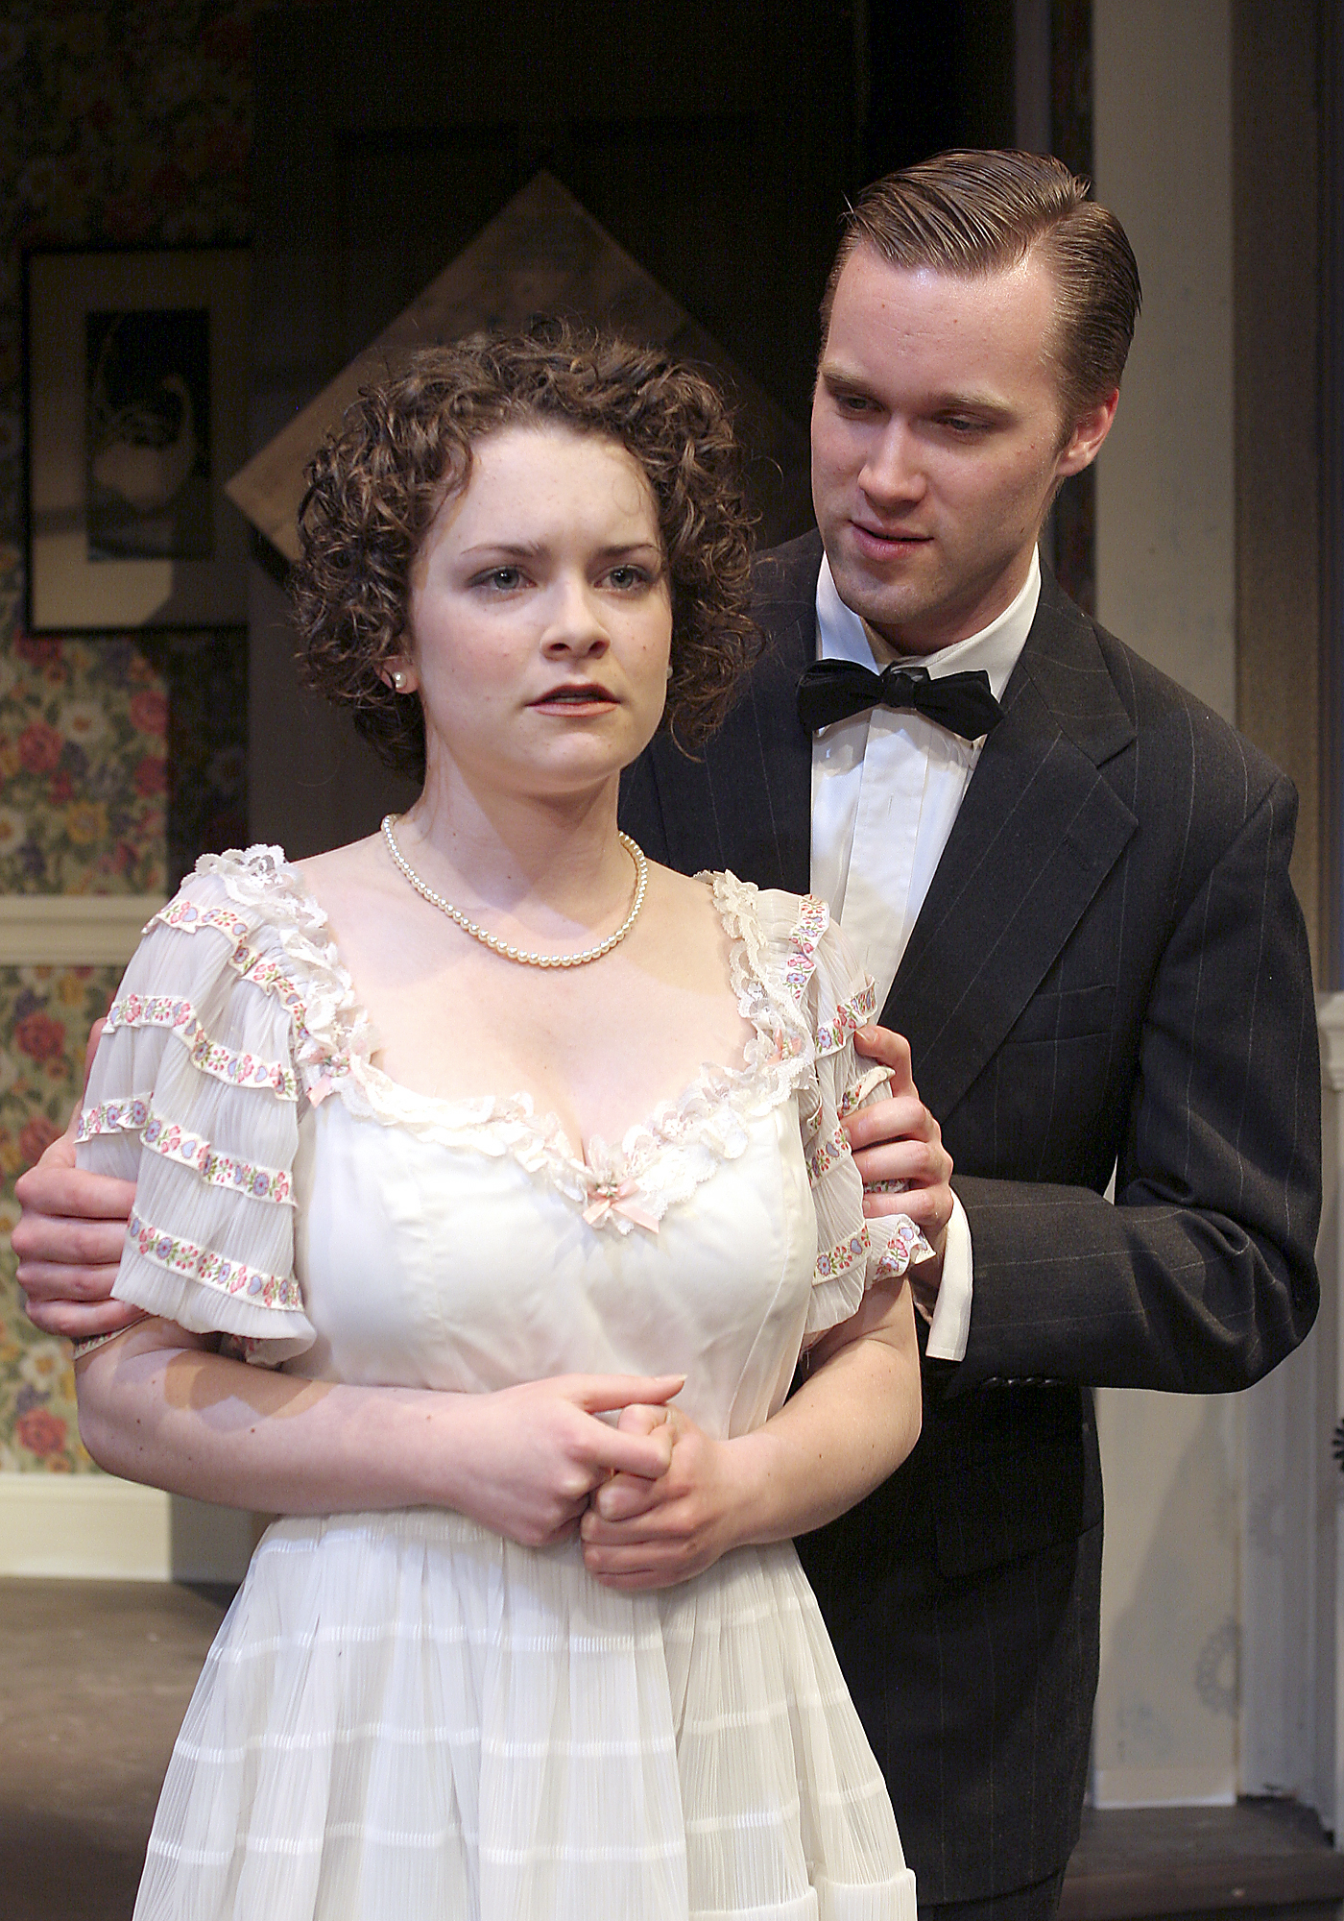
Cathryn Salamone (as Alice Sycamore) & Michael Rzepka (Tony Kirby)

** May 7 - 9 & 12 – 16 **
(Fridays & Saturdays at 8 pm, Wednesday & Thursday 7:30 pm, Sunday matinees only at 2:30 pm)
Schenectady Civic Playhouse

12 South Church St. in Schenectady’s historic Stockade District

FOR TICKETS ($15), Call (518) 382-2081
Or order on-line 24 hrs. a day at www.civicplayers.org

One of the most endearing and popular comedies of the American theater, this family-friendly, Pulitzer Prize-winning play about a hilariously unconventional family is Kaufman and Hart’s masterpiece. In “You Can’t Take It With You” the crazy, lovable Sycamore family plays impromptu hosts when their soon-to-be in-laws arrive unexpectedly for dinner. Sparks fly, literally, as the non-conformist Sycamores face-off with the ultra-traditional Kirbys. For the first visit or the third, this play puts the “nut” back in chestnut.

Featuring: Jason Biszick, Pat Brady, Jean T. Carney,
Mark Cieslak, Felicia Copeland, Kamar Elliott,
Richard Harte, Bill Hickman, Pat Hoffman,
Lonnie Honsinger, John Massaroni, John Noble,
Rita Russell, Michael Rzepka, Cathryn Salamone,
Kevin Scholz, Jennifer Van Iderstyne, & Lee Waddell

