 Opens Tomorrow, May 7!!!!
You absolutely won’t want to miss the zany, eccentric, goofy antics of the Sycamore family in . . .
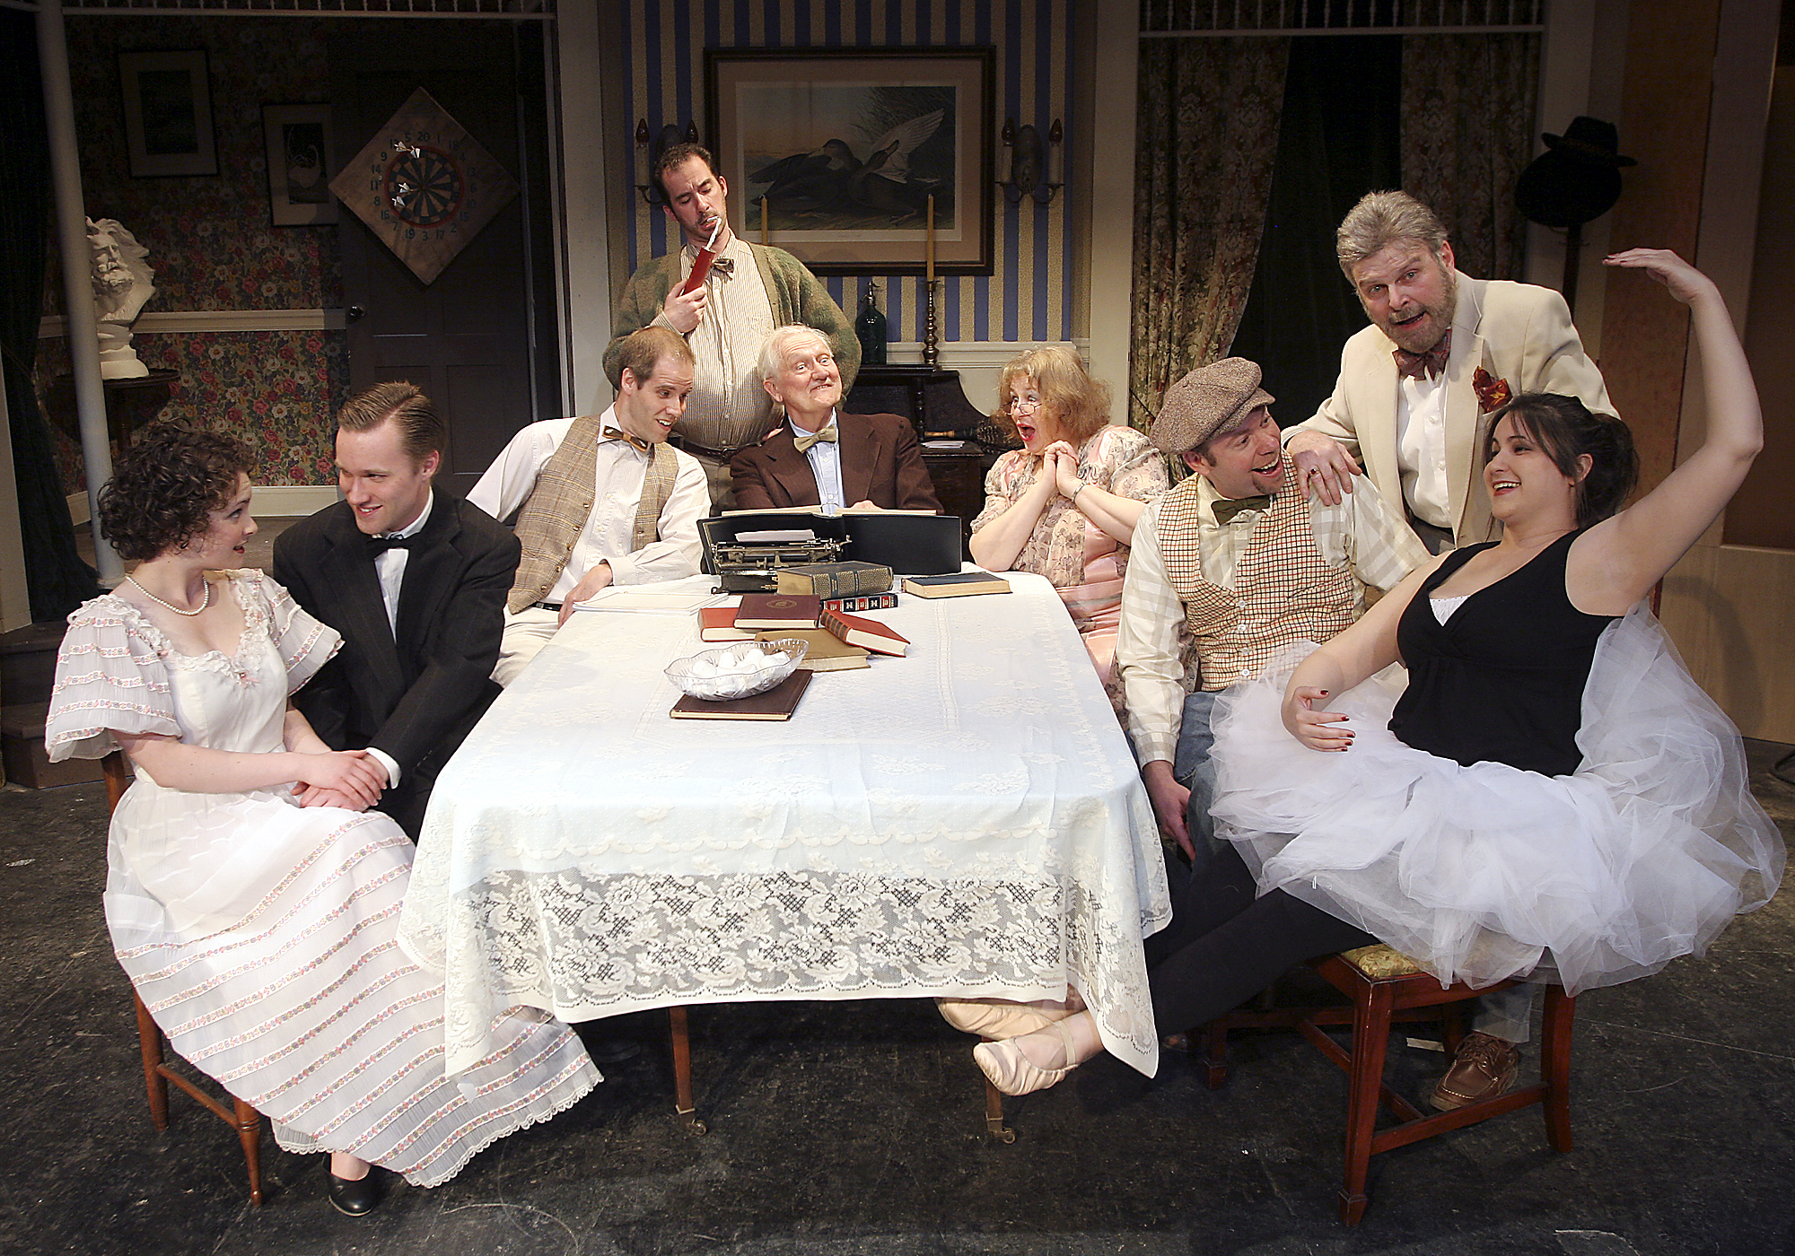
(left to right) Cathryn Salamone, Michael Rzepka, Kevin Scholz, Jason Biszick, John Noble, Rita Russell, Lee Waddell, Richard Harte, Jennifer Van Iderstyne

SCHENECTADY CIVIC PLAYERS’ production of
Kaufman & Hart’s classic comedy

Directed by Jeffrey Scott
Also featuring Pat Brady, Jean T. Carney, Mark Cieslak, Felicia Copeland, Kamar Elliott,Richard Harte, Bill Hickman, Pat Hoffman, Lonnie Honsinger & John Massaroni.

** May 7 - 9 & 12 – 16 **
(Fridays & Saturdays at 8 pm, Wednesday & Thursday 7:30 pm, Sunday matinees only at 2:30 pm)
at the Schenectady Civic Playhouse
12 South Church St. in Schenectady’s historic Stockade District

FOR TICKETS ($15), Call The Playhouse (518) 382-2081
Or order on-line 24 hrs. a day at www.civicplayers.org

