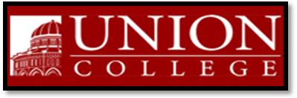
Union College Music Department
Presents

ENSEMBLE PASTOURELLE

Sunday, May 16, 2010 at 7:30 PM
Memorial Chapel, Union College
807 Union Street, Schenectady, New York 12308

Concert Free and Open to Public
Featuring
Corine Salon, Soprano Michael Clement, Piano
Susan Martula, Clarinet Leah Kidwell-Fernandes, Harp
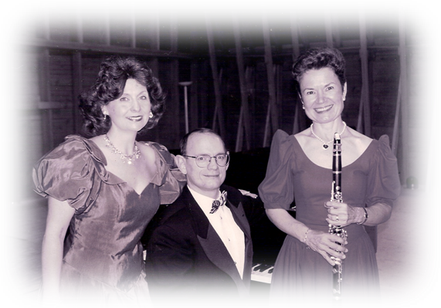
Performing Music by:
Spohr, Ravel, Grandjany, Debussy, Canteloube, Salzedo, Rodrigo

For Information Call: 388-6785 or the Music Hotline 388-6201
For reception RSVP by May 14 to csalon@nycap.rr.com

