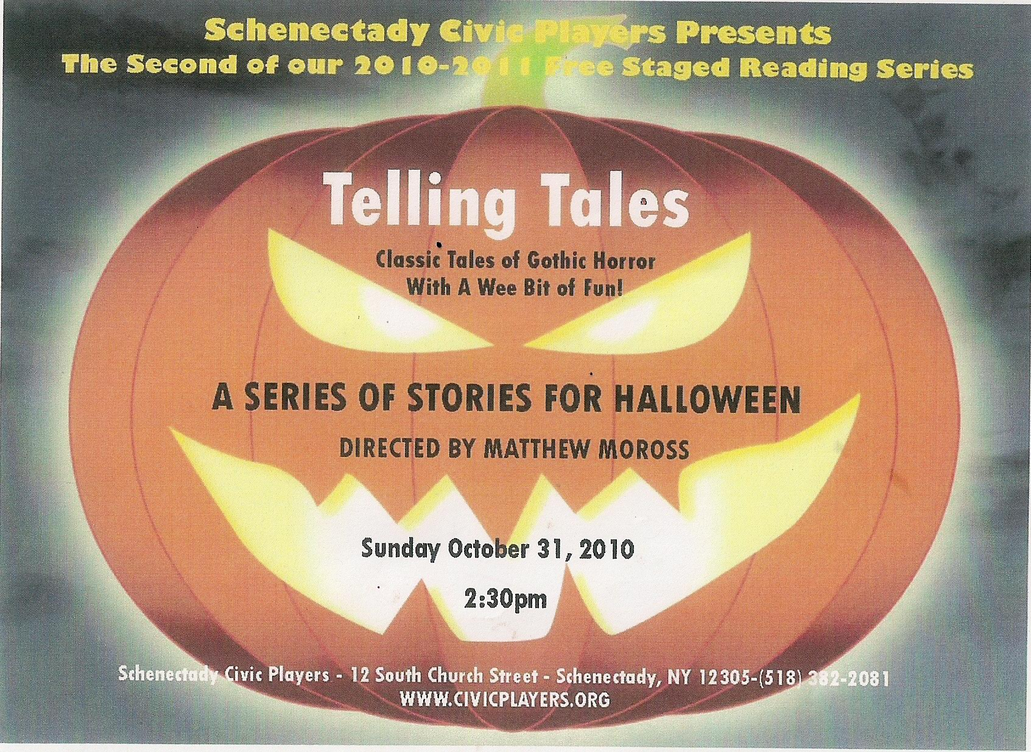
Telling Tales
Schenectady Civic Players' Next Free Staged Reading

TELLING TALES, directed by Matthew Moross, is a staged reading of classic tales of horror and suspense by masters of the genre, such as Edgar Allan Poe, Ambrose Bierce, and H.G. Wells.
Join us for these spine-tingling tales (along with a wee bit of fun) presented by Schenectady Civic Players in honor of Halloween, Sunday, October 31, at 2:30 p.m., Schenectady Civic Playhouse, 12 S. Church Street, Schenectady.
And it’s free! No reservations necessary. 382-2081.

# # # # # # # # # # # # # # # # # #

