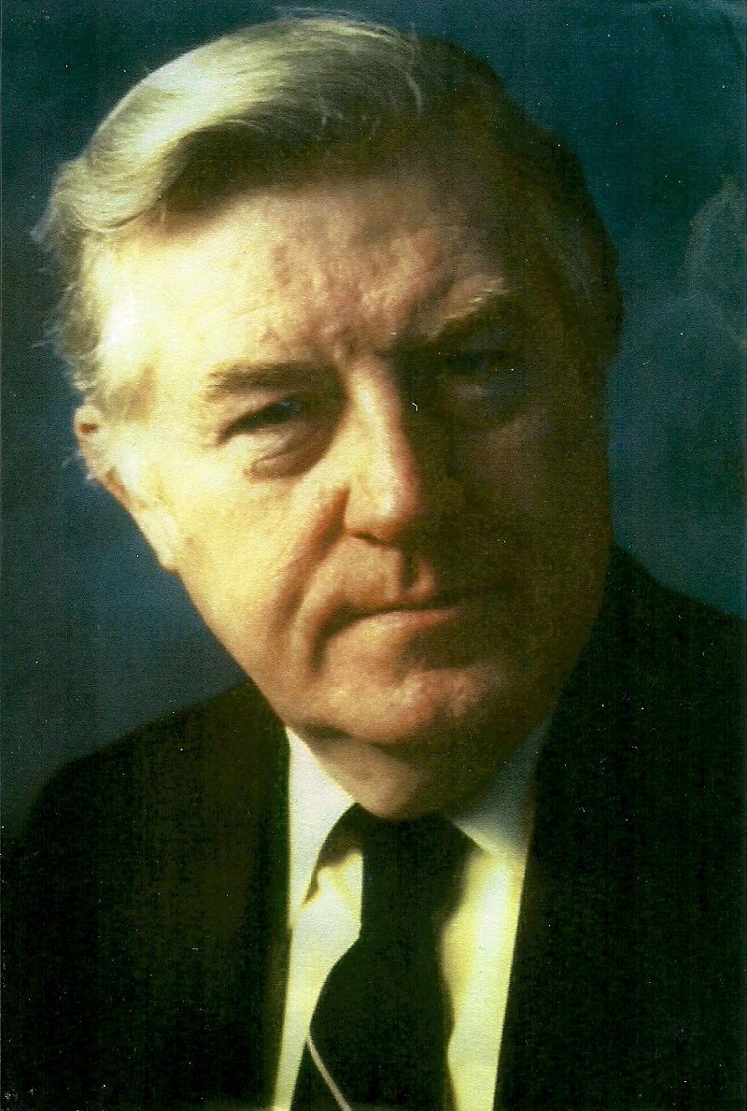 COMMUNITY ACTION THEATER SERVICES
(Martin P. Kelly, Producing Artistic Director) PROUDLY PRESENT . . .
.
The premiere of an exciting new musical cabaret . . .

Directed by Martin P. Kelly

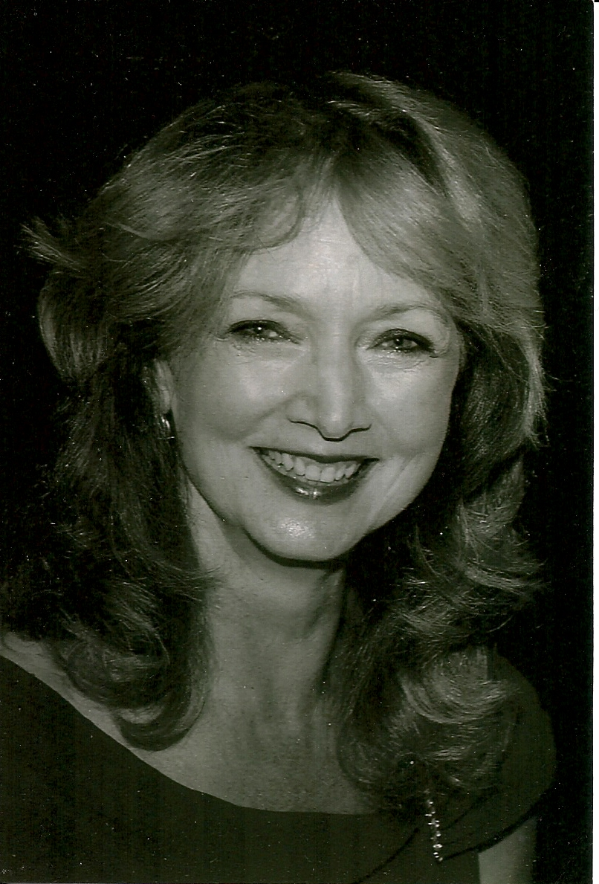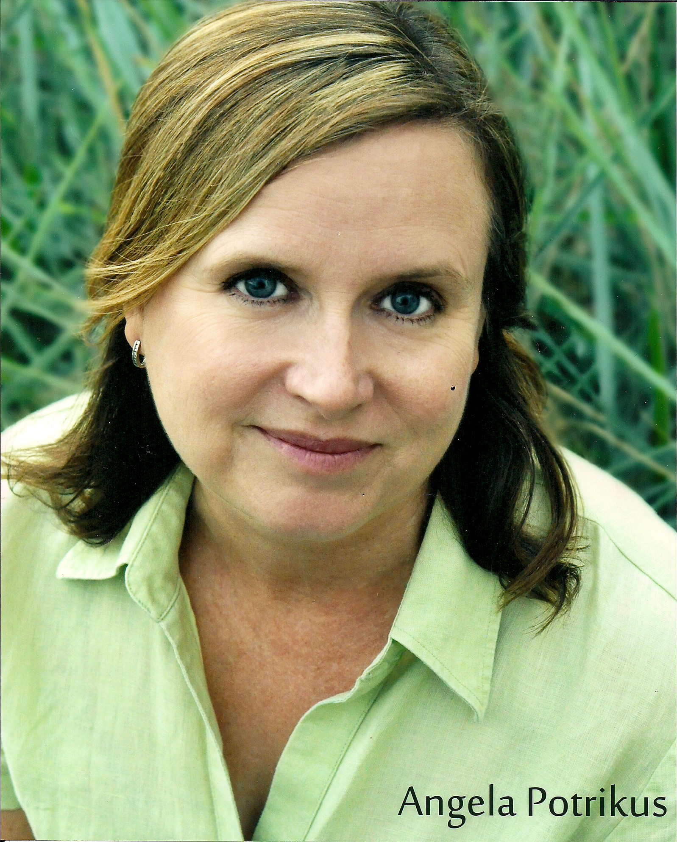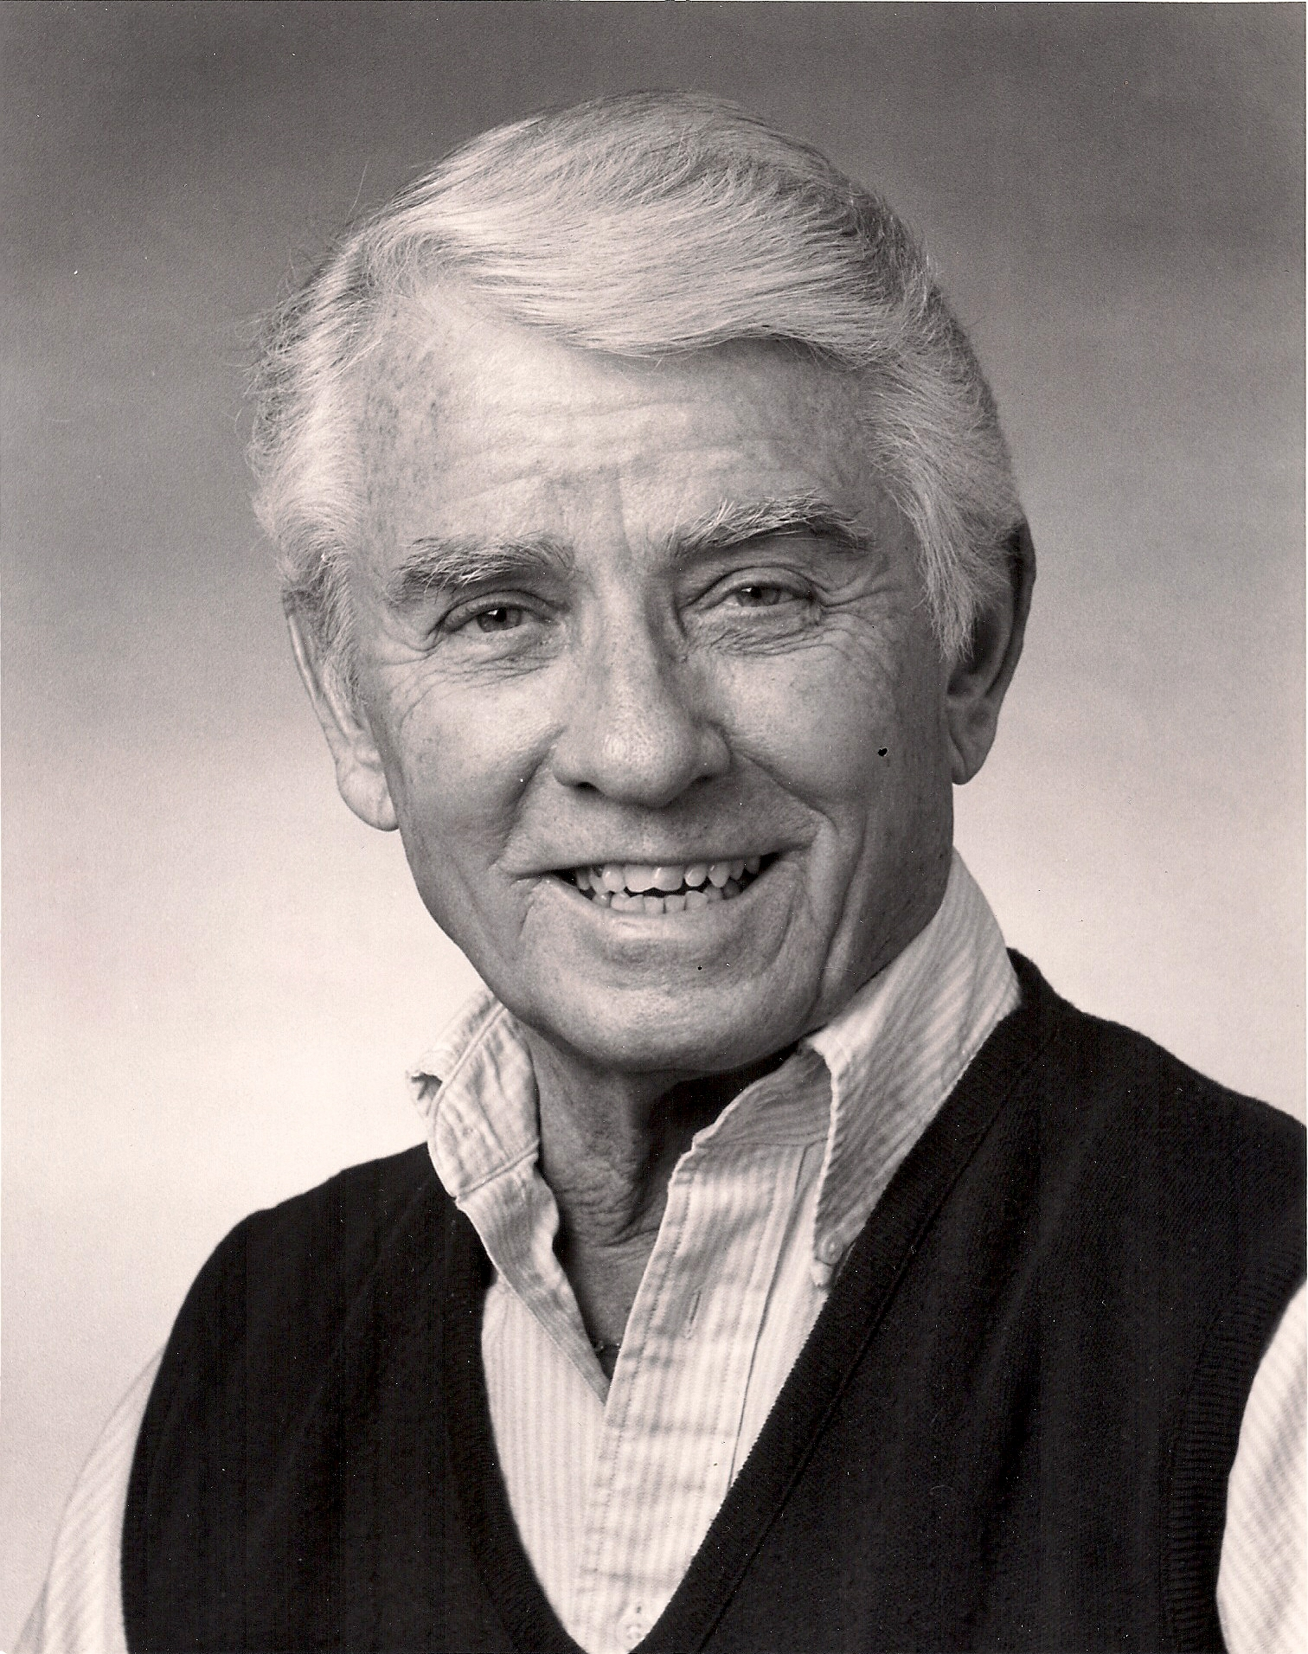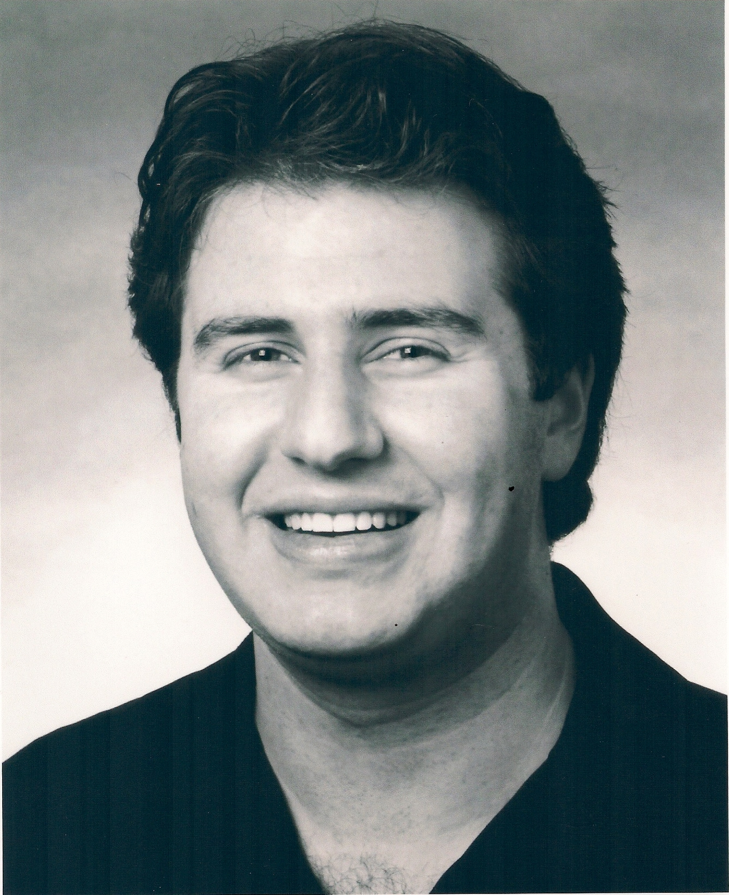
Janet Stasio Angela Potrikus William Hickman Adam Paul Fine

A musical narrative of the best songs written by Jewish composers/ lyricists over the last 100 years of Broadway productions – from Irving Berlin to Stephen Sondheim. The list is impressive including the winners of 65 percent of the Tony Awards for musical comedies.

August 27th & 28th (Saturday & Sunday)
(Saturday at 7:30 pm, Sunday matinee at 2:30 pm)

--Tickets only $10 – CALL 518-461-5411 --

-- at the --
Little Theater on the Farm
27 Plum Road, Fort Edward, NY 12828
www.littletheater27.com for more details and directions

