 Opens Friday, October 14!
Schenectady Civic Players proudly present…
. Ken Ludwig’s hilarious farce . . .

Directed by Melissa Putterman-Hoffmann
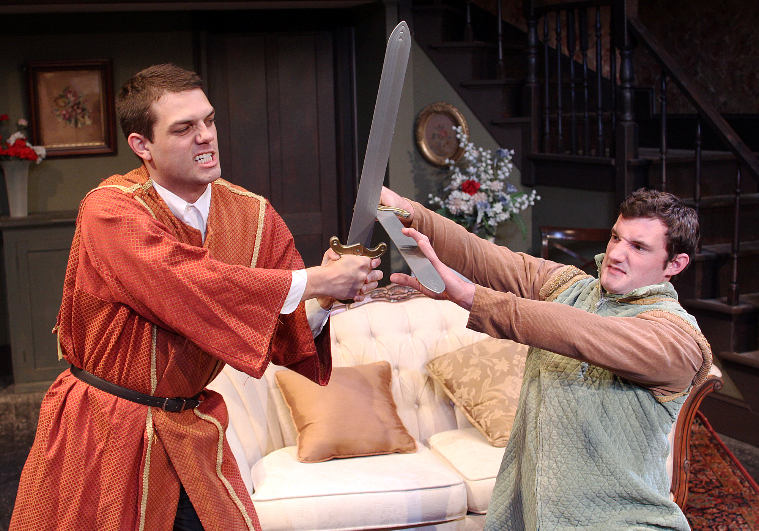
(l to r) Jimmy Cupp and Paul Dederick
-- October 14, 15, 16 & 19 – 23 --
(Fridays & Saturdays at 8 pm, Wednesday & Thursday 7:30 pm, Sundays matinees only at 2:30 pm)
(From the author of Moon Over Buffalo” and Lend Me a Tenor.) In Leading Ladies meet Jack (played by Jimmy Cupp) and Leo (Paul Dederick), English Shakespearean actors whose fortunes have sunk to performing “Scenes from Shakespeare” on the Moose Lodge circuit in rural Pennsyolvania. Hearing that a wealthy matron in nearby York is about to die, they conspire to impersonate her two long lost nephews and get the cash. The trouble is the missing relatives aren’t nephews, but nieces. Add in some romance and mischief, and try to keep up as, undaunted, these two thespians forge ahead with their harebrained scheme! Making up the cast are Jimmy Cupp, Ryan Davis, Paul Dederick, Sally Farrell, Meigg Jupin, Amy Lamena, Phil Sheehan, and Mark Stephens.
at the Schenectady Civic Playhouse
12 South Church St. in Schenectady’s historic Stockade District
FOR TICKETS ($15), Call The Playhouse (518) 382-2081
Or order on-line 24 hrs. a day at www.civicplayers.org

