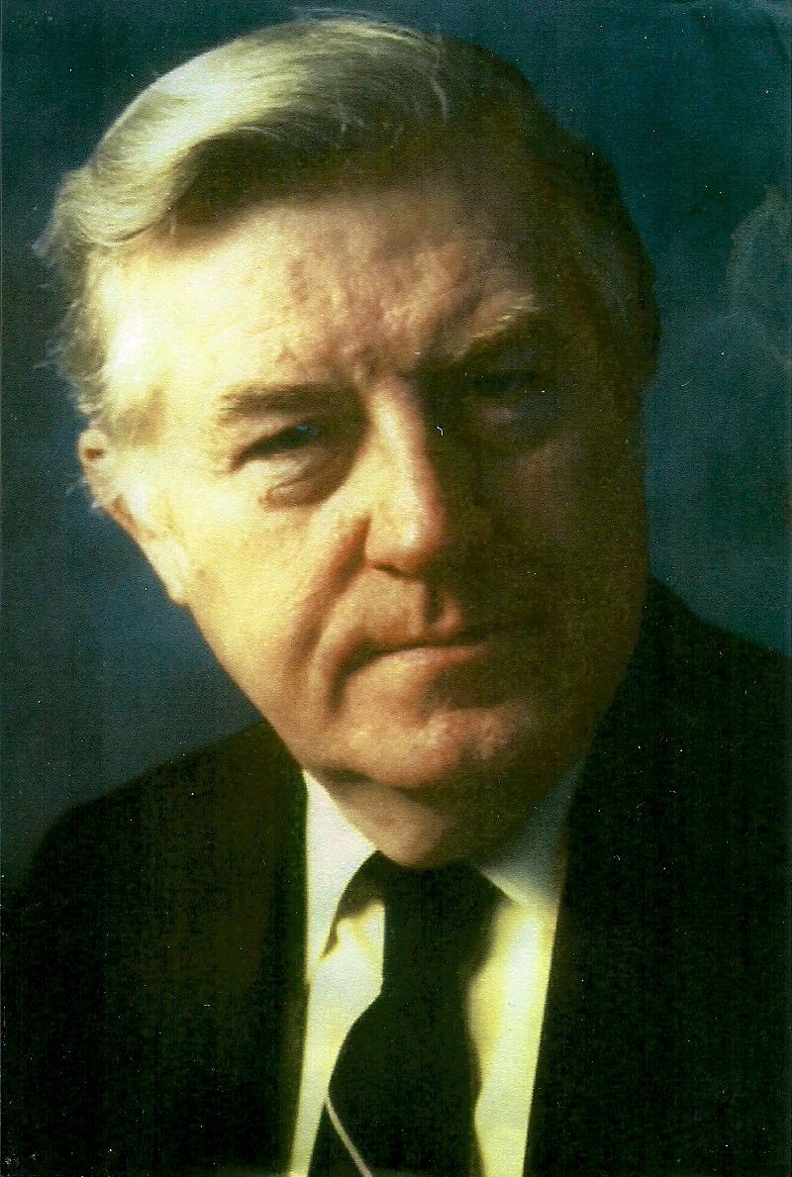 COMMUNITY ACTION THEATER SERVICES
(Martin P. Kelly, Producing Artistic Director) PROUDLY PRESENT . . .
.
The premiere of an exciting new musical revue . . .

Directed by Martin P. Kelly

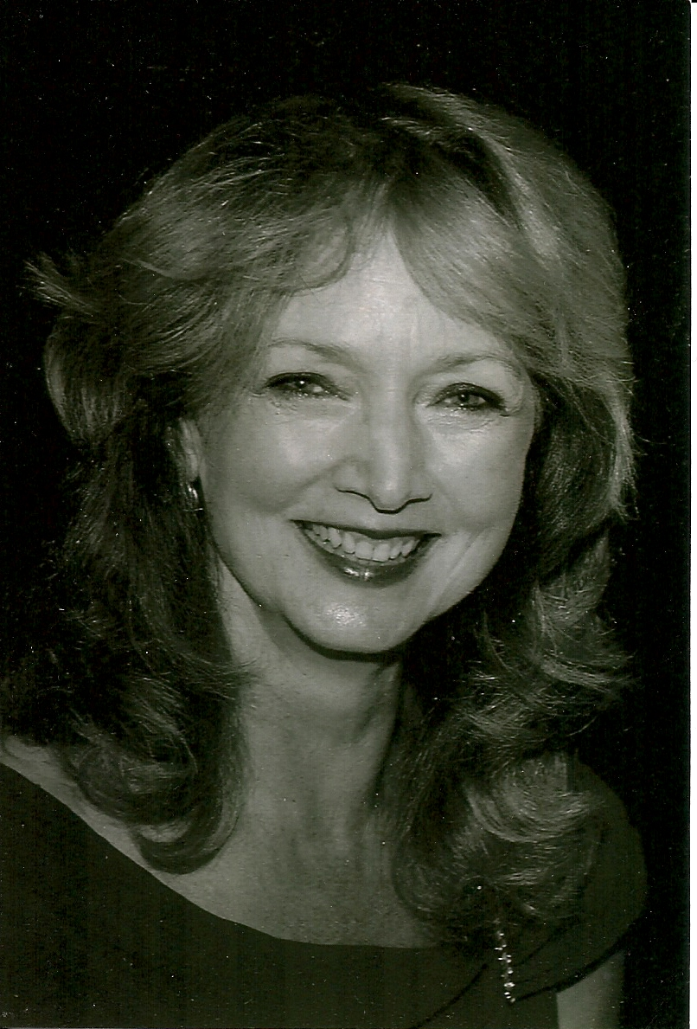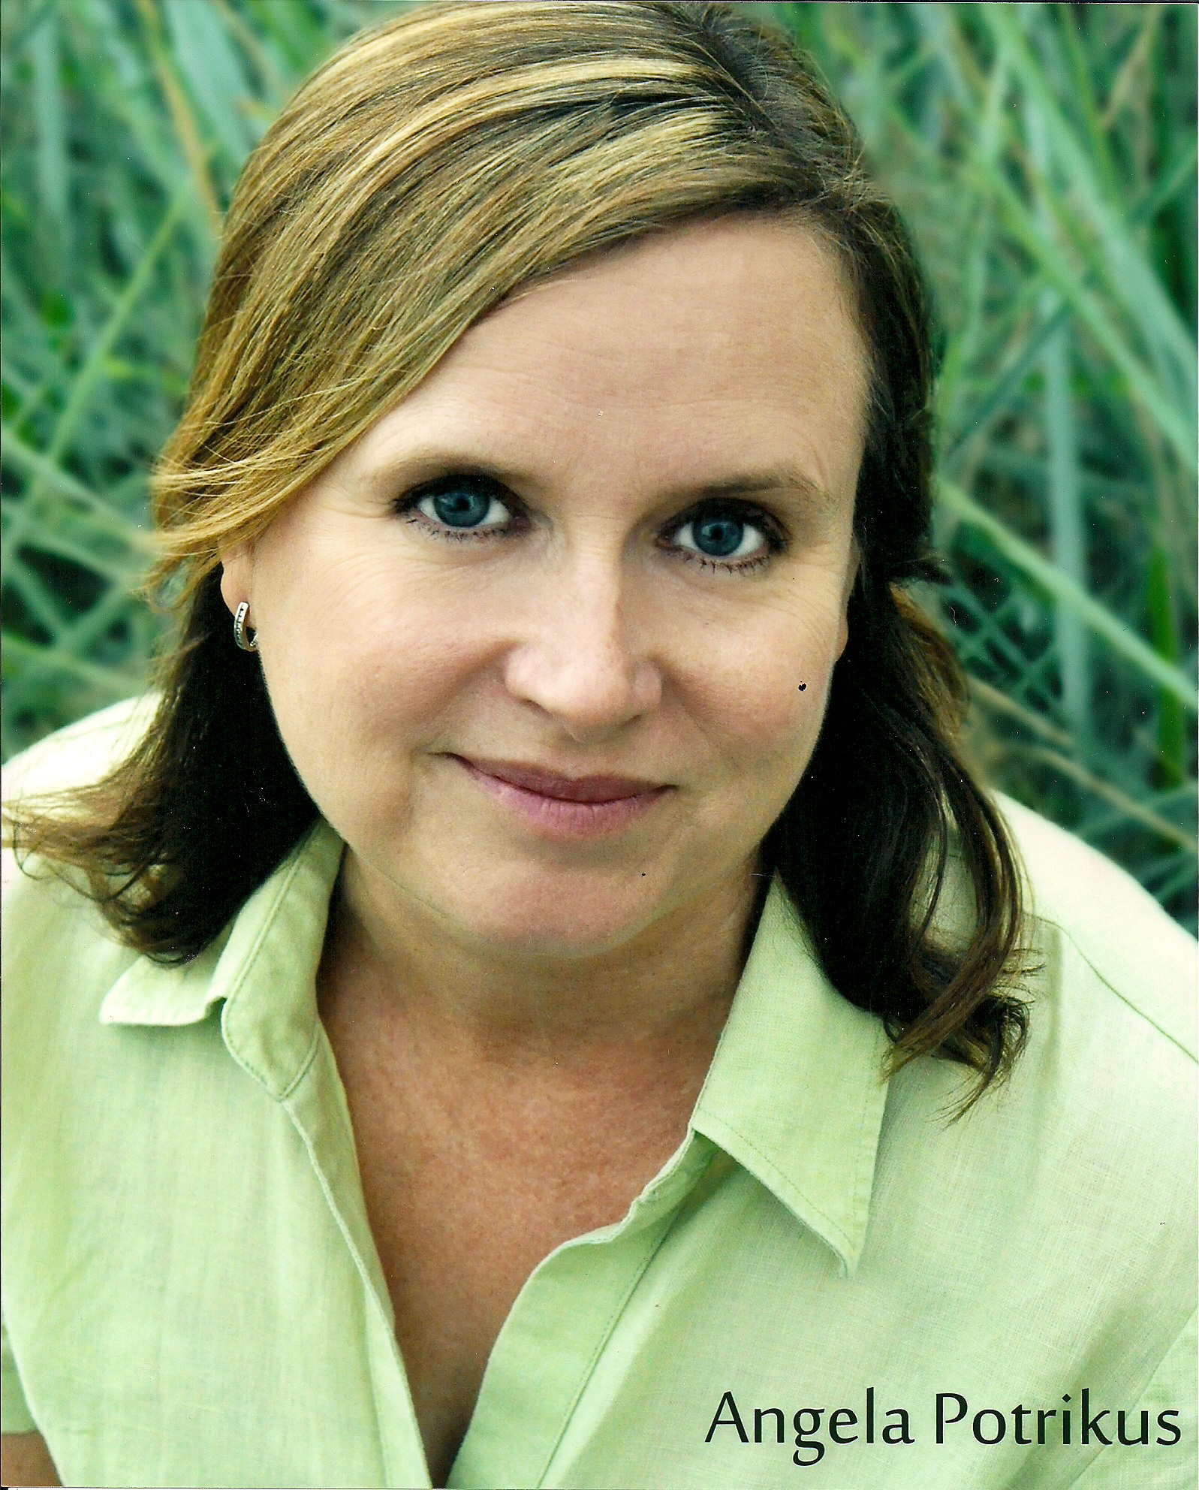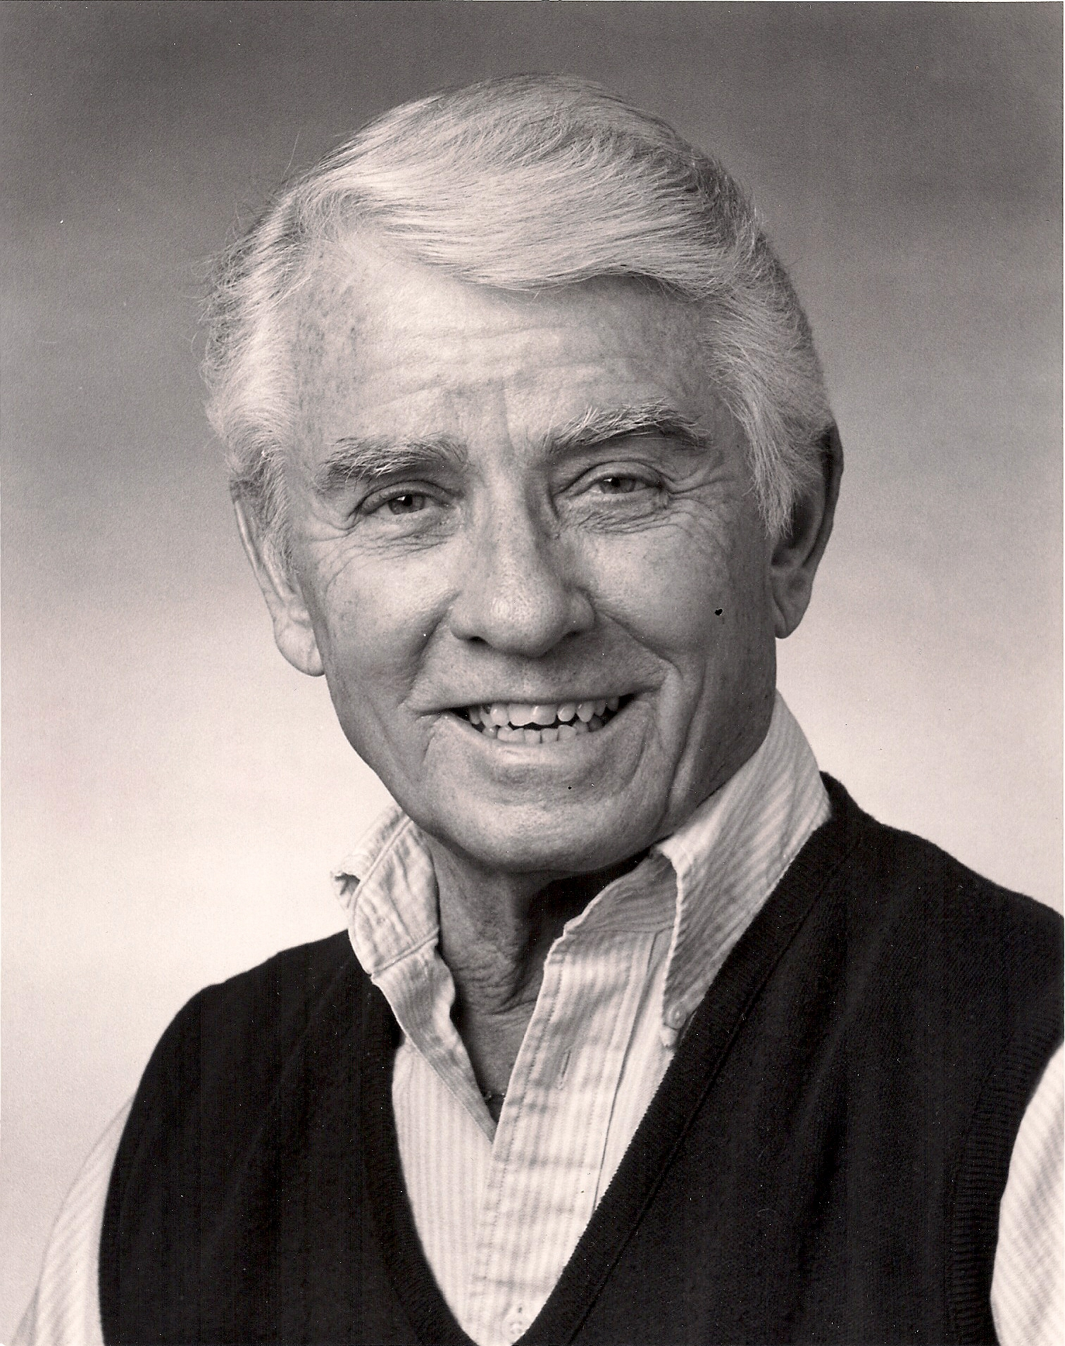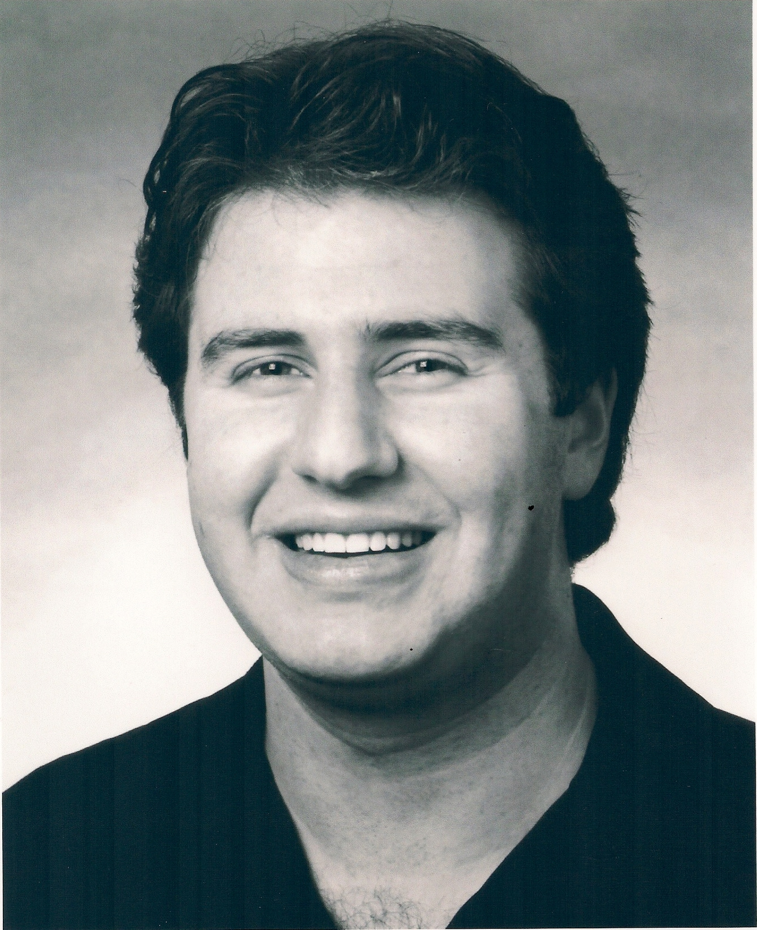
Janet Stasio Angela Potrikus William Hickman Adam Paul Fine
Musical director Vince Bonafede on keyboard
A musical narrative of the best songs written by Jewish composers/ lyricists over the last 100 years of Broadway productions – from Irving Berlin to Stephen Sondheim. The list is impressive, including the winners of 65% of the Tony Awards for musical comedies. Written and produced by Martin P. Kelly as part of a national library system celebration of these composers.

-- Sunday, December 4, at 2 p.m. --
--FREE –
(No advance reservations)
at the Bethlehem Public Library
451 Delaware Avenue, Delmar, NY

