Spotlight_Contact_Logo[1]

**STAGED READING SERIES**

****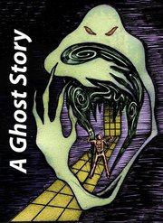

**Directed by Joy Perret**

**Presented February 12, 2012 at 2:00 pm**

**East Greenbush Community Library**

**Free Admission**