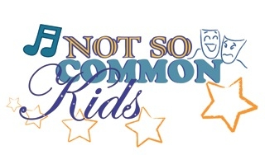

The Not So Common Players of Clifton Park Announce
Summer Camp Scholarship Opportunity

The Not So Common Kids Summer Camp in Clifton Park has recently been awarded a grant from Stewart’s Holiday Match. This grant has enabled Not So Common Kids to offer two scholarships of $125 each to be applied to the $400 camp fee for each of two students. There is an application process that must be followed to be eligible for the scholarship.

Scholarship applications are available at the Clifton Park Town Clerk’s Office, One Town Hall Plaza, Clifton Park NY and can also be found on the Not So Common Players website, http://notsocommonplayers.org/. Deadline for submission is Friday June 8, 2012.

Not So Common Kids Summer Camp is a theatre camp for students ages 8-14, and runs from July 2 – 21. Students meet Monday through Friday from 9 – 3. While at the camp, students learn about different aspects of theater including acting, singing, costumes, make-up, props, lighting and sound. Additionally, students rehearse and perform a show; this year’s show will be Annie Jr. The show is performed at the Clifton Common Stage on July 20 and 21.

