 SCHENECTADY CIVIC PLAYERS proudly present

By TOM STOPPARD Directed by Chris Foster
a searingly insightful, brutally honest, wonderfully comic, endearingly romantic adult comedy
-- May 4, 5 & 6 and May 9 through 13 --
( ( Fridays & Saturdays at 8 pm, Wednesday & Thursday 7:30 pm, Sundays matinees only at 2:30 pm)

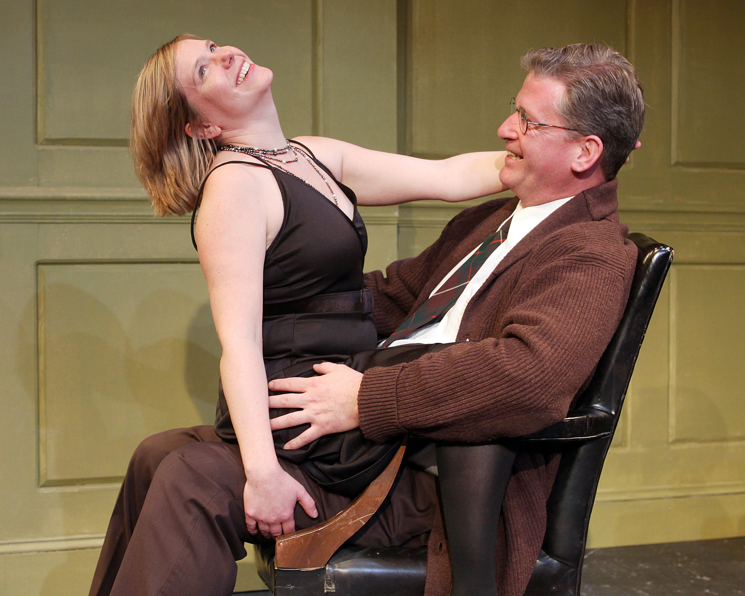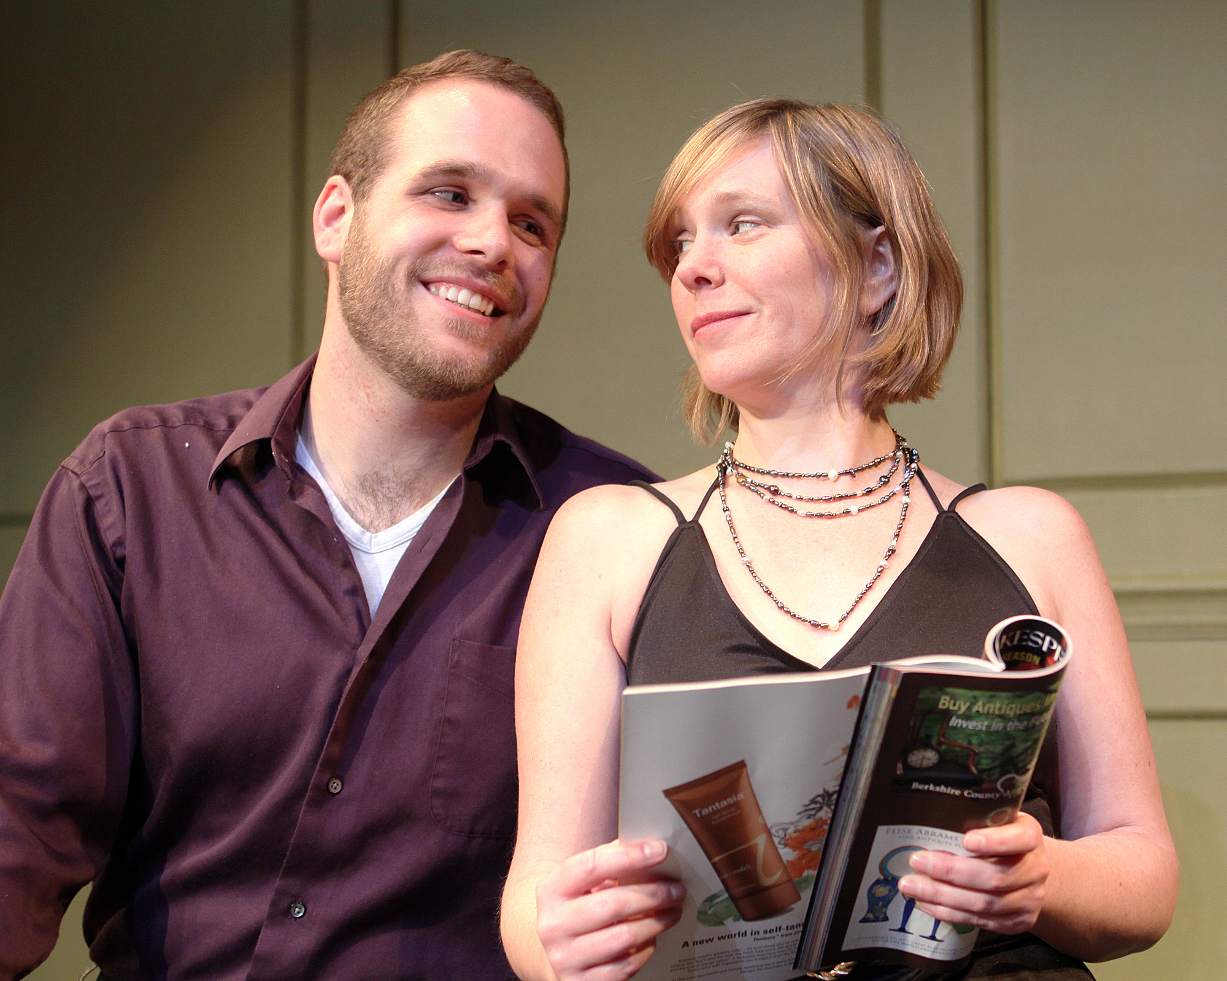
Amy Lane and Patrick White Pat Rooney and Amy Lane
Tom Stoppard, the Oscar-winning writer of the movie Shakespeare in Love, creates an adult comedy full of the pain and the folly of love. A two time Tony Award winner, this intellectually and whose second wife is trying to merge worthy causes with her art as an actress. She has met a "political prisoner" named Brodie who has been jailed for radical thuggery, and who has written an inept play about how property is theft and how the state stifles the rights of the individual.
Making up the cast of veteran Schenectady Civic Players and Capital District performers are Judie Bouchard, Anna Kroup, Amy Lane, Ben McCauley, Duncan Morrison, Pat Rooney and Patrick White.

at the Schenectady Civic Playhouse
12 South Church St. in Schenectady’s historic Stockade District (518) 382-2081
TICKETS ($15). Purchase in person at Proctors Box Office, 432 State Street. Order and charge by phone at (518) 346-6204. Or order on-line 24 hrs. a day at www.civicplayers.org

