FOR IMMEDIATE RELEASE:
SLOC Publicity Coordinator-Jonathan Pate, 518-953-7055, jonathanrpate@gmail.com
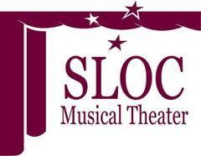
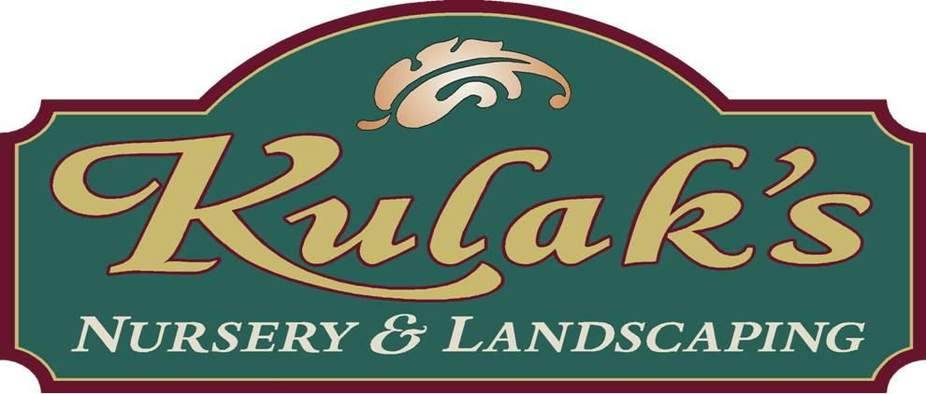

Schenectady Light Opera Company's
Youth Theatre Program

Sponsored by
Kulak's Nursery & Landscaping

Presents
The classic cult musical
Little Shop of Horrors
Music by Alan Menken
Book and Lyrics by Howard Ashman
Directed by Sev Moro

(SCHENECTADY, NY) Little Shop of Horrors, is the second production of Schenectady Light Opera Company’s (SLOC) 2012-2013 season and will run from December 7-9th and 13-16th, 2012. The Capital Region community theatre in downtown Schenectady is celebrating its 86th season under the leadership of John Samatulski, Executive Director, and Robert Harrison, President. Little Shop of Horrors is directed by Sev Moro (SLOC’s Baby & Les Miserables).

Little Shop of Horrors is the story of a down-and out skid row floral assistant who becomes an overnight sensation when he discovers an exotic plant with a mysterious craving for fresh blood. Soon "Audrey II" grows into an ill-tempered, foul-mouthed, R&B-singing carnivore who offers him fame and fortune in exchange for feeding its growing appetite, finally revealing itself to be an alien creature poised for global domination! Little Shop of Horrors had its world premiere on May 6, 1982 at the Workshop of the Players' Art (WPA) Theatre. The production opened off-Broadway at the Orpheum Theatre on July 27, 1982. This original production, directed by Howard Ashman, with musical staging by Edie Cowan, was critically acclaimed and won several awards including the 1982-1983 New York Drama Critics Circle Award for Best Musical, the Drama Desk Award for Outstanding Musical, and the Outer Critics Circle Award. When Little Shop of Horrors closed on November 1, 1987, after 2,209 performances, it was the third-longest running musical and the highest-grossing production in off-Broadway history. The production ran for 5 years. The musical finally made its Broadway debut at the Virginia Theatre on October 2, 2003 with a cast including Hunter Foster as Seymour, Kerry Butler as Audrey, Rob Bartlett as Mr. Mushnik, Douglas Sills as Orin, Michael-Leon Wooley as the voice of Audrey II, and DeQuina Moore as Chiffon.

Schenectady Light Opera Company’s Little Shop of Horrors cast will feature Stephen McCauley, Jr. as Seymour, Allie Mantica as Audrey, Sarah Beitch as Mrs. Mushnik, Edward Ryan as Orin and others, Alexis Rivera as Ronnette, Gabrielle Straight as Chiffon, India McKinney as Crystal, Sawyer Harrington-Verb as Audrey II (Voice)/ Wino, Austin Liebers as Audrey II (Puppeteer), Will Whisenhunt as Ensemble/Seymour Understudy, Marina Macherone as Ensemble/Audrey Understudy, Giuliana Bruno as Ensemble/Dance Captain, Olivia Cafarelli as Audrey II (Baby Plant), Maureen Gallagher as Ensemble, Juliana Kopa as Ensemble, Connor Olney as Ensemble, Gabriella Pizzolo as Ensemble/Old Chinese Man, Julia Santana as Ensemble/Bag Lady, Anna Starr as Ensemble, Alex Whisenhunt as Ensemble.
Sev Moro directed last season’s BABY and the extremely successful Youth Program production of LES MISERABLES, in 2011. With over thirty years of experience, both on-stage and behind the scenes, Sev has directed, designed and performed, professionally, for Syracuse Stage, Vermont Stage, Florida Studio Theater, Fort Salem Theater, Busch Gardens and Disney Productions. Locally, in addition to Schenectady Light Opera Company, he has worked with Curtain Call Theater, Center Stage Productions, Family Players of NENY, Homemade Theater, Not-So-Common Players, Schenectady Civic Players and the Local Actors Guild of Saratoga. Sev is Schenectady Light Opera Company’s Artistic Director and a current member of the Board of Directors.
The Schenectady Light Opera production will also feature a production team that includes Director Intern-Josh Rivera, Music Director-Brandon Jones, Choreographer-Christine Marcella, Production Assistant-Suzanne Rucinski, Production Stage Manager-Kathy Schechtman, Costume Designer-Debbie Lummis, Lighting Designers-Greg Rucinski and Bob Healey, Scenic Designer-Sev Moro, Sound Designer-Michael Silvia, Hair Designer-Joseph Austin Kennedy, Make-up Designer-Marcia Lenehan, Audrey II Manipulation Supervisor-Amanda Jo Marshall, and Props-Amanda Jo Marshall.

Schenectady Light Opera Company's production has been generously sponsored by Kulak's Nursery located in Rexford, New York. Kulak's Nursery and Landscaping began in 1982 as a small family owned and operated landscaping business. After twenty years of servicing the capital district in upstate New York, Kulak's expanded their landscape business into a garden center including a nursery and unique gifts and home decor store. Since 2002 Kulak's has grown new branches, blossoming as one of the finest locally owned garden centers in the capital region. The goals of Kulak’s Nursery & Landscaping owners and staff are to provide quality customer service, garden knowledge and expertise, and quality products and workmanship. Kulak's carries everything from your garden variety trees, shrubs and perennials to your native woodland perennials and rare variegates and more. And if you don’t see it in our nursery, Kulak's will find it for you!
Little Shop of Horrors will be presented at Schenectady Light Opera House, 427 Franklin Street, Schenectady. Performance dates and times: Thursday-Saturday at 8pm and Sunday at 2pm. Tickets: $18-$28. Tickets may be purchased at the Box Office at Schenectady Light Opera House, on the phone at 877-350-7378, or online at www.sloctheater.org.

About Schenectady Light Opera Company
Schenectady Light Opera Company (SLOC) is a nonprofit community theater organization in Schenectady, New York, established in 1926. The current location of the theater is at the new performing art center at 427 Franklin Street, in downtown Schenectady. The 2012-2013 season includes Next to Normal, Little Shop of Horrors, Dirty Rotten Scoundrels, The Sound of Music, and Sweet Charity. The company has presented over 500 shows at various locations for over 85 years. www.sloctheatre.org.

