-- OPENS MARCH 15! TICKETS NOW ON SALE! –
SCHENECTADY CIVIC PLAYERS
proudly present the 4th play of its 85th Season . . .
Alan Ayckbourn’s brilliant and biting black comedy . . .

Directed by Tom Heckert
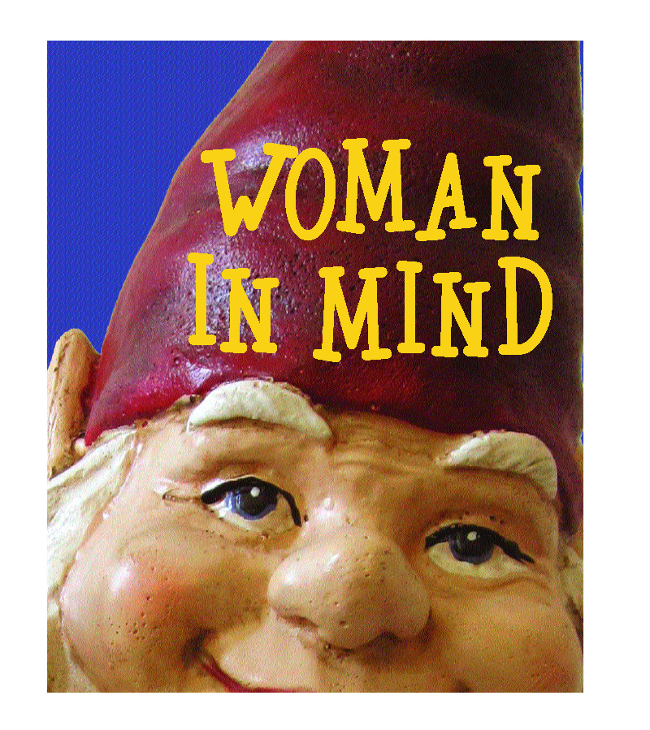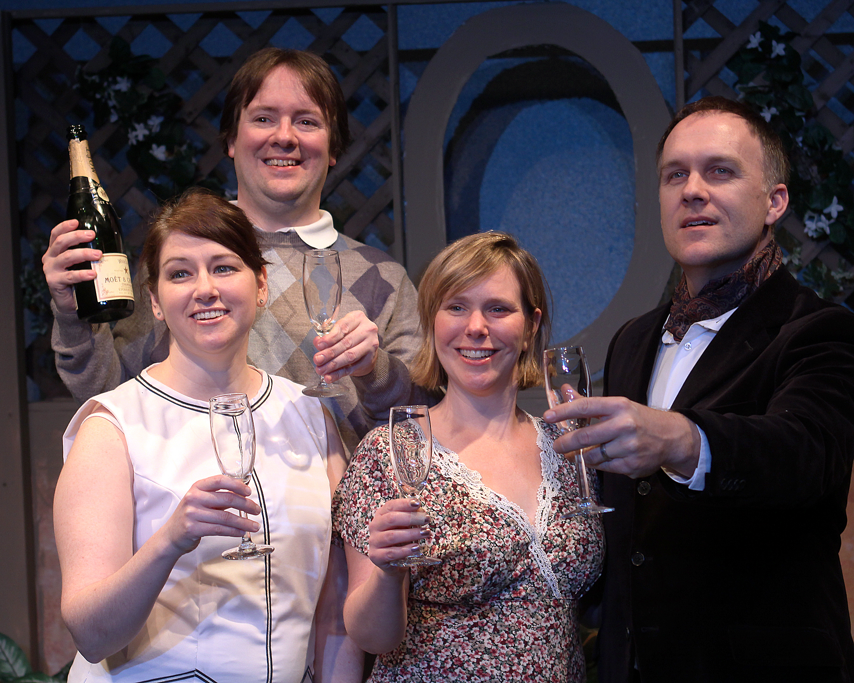
(left to right ) Allyson M. Kelly, John A. Nickles, Amy M. Lane, Jeremy Clowe

An outstanding drama from Britain’s comedy genius. Ayckbourn, an Olivier and Tony Award winning playwright, has written 77 plays including The Norman Conquests, Absurd Person Singular, and Life of Riley.

After stepping on the toothed end of a garden rake, Susan experiences hallucinations in which her boring and oppressive everyday life is replaced by a fantasy. Now she is the ideal wife with the ideal family! But is this merely bliss, or has she merely let her sanity lapse? “The Secret Life of Walter Mitty meets Blithe Spirit meets The Exorcist.”

The eight member cast features Amy M. Lane (as Susan), Victor L. Cahn (as Bill), Jeremy Clowe (Andy), Allyson M. Kelly (Lucy), John A. Nickles (Tony), Marty O’Connor (Gerald), Joan Justice (Muriel), and Ben McCauley (Rick).

-- March 15, 16 & 17 and 20 thru 24 --
(Fridays & Saturdays at 8 pm, Wednesday & Thursday 7:30 pm, Sundays at 2:30 pm)
at the Schenectady Civic Playhouse

12 South Church St. in Schenectady’s historic Stockade District
TICKETS ($15). Purchase in person at Proctors Box Office, 432 State Street, Schenectady.
Or order and charge by phone at (518) 346-6204.
Or order on-line 24 hrs. a day at www.civicplayers.org

