-- OPENING FRIDAY, MAY 3. TICKETS ON SALE --
SCHENECTADY CIVIC PLAYERS .
proudly present the 5th play of its 85th Season . . .
The Stephen Sondheim/James Lapine prize winning musical . . .

Directed by Duncan Morrison - Musical direction Valerie Lord
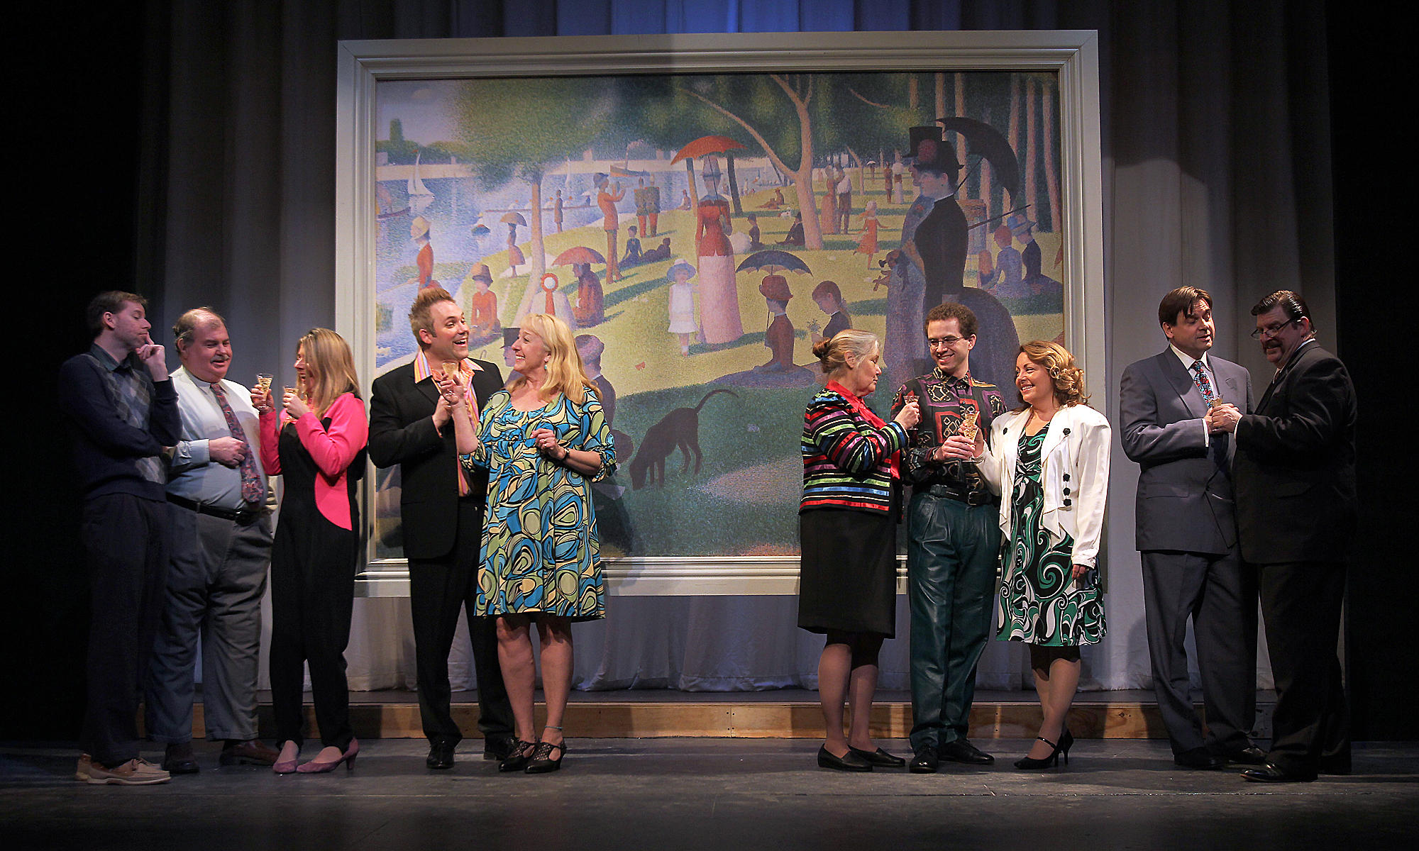
(to r) Kris Anderson, Joe Phillips, Karen Kolterman, Shawn Haun, Judi Merriam, Donna Carsten,
Nathan Perry, Sue Caputo, Peter Lacjian, Chris Foster

Inspired by Georges Seurat’s famous painting, “A Sunday Afternoon on the Island of La Grande Jatte”, this Sondheim/Lapine musical is one of the most-acclaimed shows of our time. Brimming with beauty and light, it is a deeply insightful and highly personal examination of life through art and the artist. “An audacious, haunting and touching work.”

“Sunday in the Park with George” won the 1985 Pulitzer Prize for drama, two Tony Awards for design (and a nomination for Best Musical), numerous Drama Desk Awards, the 1991 Olivier Award for Best Musical, and the 2007 Olivier Award for Outstanding Musical Production.

The cast features Hailey Aldrich (Louise), Kris Anderson (Franz/Dennis), Sue Caputo (Frieda/Betty), Donna GouldCarsten (Old Lady/Blair), Chris Foster (Boatman/Redmond), ShawnHahn (Louis/Billy), KarenKolterman (Yvonne/Naomi), Peter Lacijan (Jules/Greenberg), Molly McGrath (Dot/Marie), Judi Merriam (Nurse/Misses/Harriet), Matthew Moross (Georges/George), Nathan Perry (Soldier/Alex), Joe Phillips (Mister/Randolph), Sarah Nicole Ruddy (Celeste #2/Elaine), and Elizabeth Sterling (Celeste #1/Cocktail waitress).
-- May 3, 4 & 5 and 8 thru 12 --
(Fridays & Saturdays at 8 pm, Wednesday & Thursday 7:30 pm, Sundays at 2:30 pm)
at the Schenectady Civic Playhouse

12 South Church St. in Schenectady’s historic Stockade District
TICKETS ($18). Purchase in person at Proctors Box Office, 432 State Street, Schenectady.
Or order and charge by phone at (518) 346-6204.

