Young Actors Guild of the Capital Region
Presents:

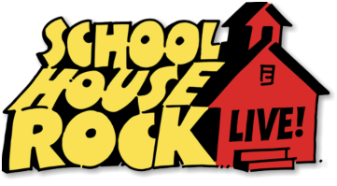

Originally Adapted and Produced for the Stage by Theatre BAM
From the Series Created by George Newall and Tom Yohe
Based on an idea by David McCall
Book by Scott Ferguson, George Keating, and Kyle Hall
Music and Lyrics by Lynn Ahrens, Bob Dorough,
David Frishberg, Kathy Mandry, George Newall,
and Tom Yohe
Who: Young Actors Guild of the Capital Region
When: May 17, 18, 7:30PM, May 19th 2:00PM
Where: RPI Playhouse – 15th Street, Troy, NY
For Reserved Tickets call 276-6505 – Paid Reserve tickets - $10.00- At the Door - $12.00

The Students of the Young Actors Guild Spring Session present the 70’s Hit “Schoolhouse Rock Live”
With all of the old time favorite tunes like Conjunction Junction, and Interplanet Janet! This show is appropriate for ages 0 – 99! Come and support these young actors as many of them have their first experience on stage!

