WHITEHALL’S BRIDGE THEATER CELEBRATES 150TH ANNIVERSARY OF THE AMERICAN CIVIL WAR (This Saturday at Noon)
Includes picnic lunch and the celebration - $15.00 for adults and $13 for students 17 and younger. Reservations are available at 518/499-0477.

WHITEHALL, NY-- A re-created 19th century picnic grove will be the site of a Bridge Theater celebration of the 150th anniversary of the American Civil War beginning at noon, Saturday, August 24.
The theatrical re-creation, open to the public, will take up all the parade floor of the former Whitehall Armory, renamed the Whitehall Athletic Club when Greg Gross, a New Jersey insurance broker, purchased the 110-year old structure in 2010. Location is Poultney (Route 4) and Williams Streets, Whitehall, NY
Produced and directed by Martin P. Kelly for the Bridge Theater, the celebration will be presented as a mid-Civil War picnic at which Abraham Lincoln re-enactor Phil Jessen of Hartford in Washington County, will appear following the picnic lunch prepared by the Athletic Club's staff for all attendees.
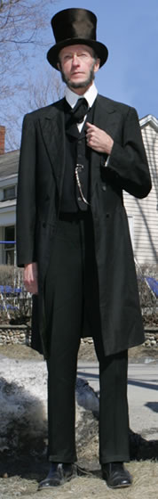
Phil Jessen as President Lincoln

During lunch, the audience will be serenaded by the 77th Regimental
Balladeers, a group of a dozen musicians and singers who are also
Civil War re-enactors. This troupe
appears a good six months a year at
such events throughout the northeast, and earlier this summer appeared at the Gettysburg battlefield.

Following lunch, Lance Ingmire, President of the Friends of the NYS
Military Museum at Saratoga, and the Balladeers will welcome President Lincoln.

Jessen as Lincoln will discuss his arrival in Washington as
President, and the lead up to the Civil War, while relating the purpose of his Emancipation Proclamation. He will conclude with the deliverance of his Gettysburg Address as given in 1863 shortly after the famed battle.

Following President Lincoln's appearance, Lance Ingmire will introduce actors from the Bridge Theater company who will present letters from Civil War soldiers who were Whitehall residents, in dramatic form with musical background by The 77th Regiment Balladeers. Lance Ingmire will conclude the afternoon's official program with a Power Point demonstration of photographs taken by his great-great grand-uncle who was Lincoln's photographer. Ingmire is a ninth generation resident of Saratoga County.

The Balladeers, led by John Quinn of Greene County, will lead the
audience in songs of the Civil War period as the gathering of visitors
prepare to leave the picnic grounds in the former state armory.

(The Lower Adirondack Regional Arts Council (LARAC) in Glens Falls has provided a small grant from New York Arts Council funds to enlist the aid of the musicians, speakers and actors.)

