-- OPENS NEXT FRIDAY, DECEMBER 6 –

SCHENECTADY CIVIC PLAYERS .
present David Sedaris’ merry and hilarious . . .
The Santaland Diaries
Directed by Duncan Morrison

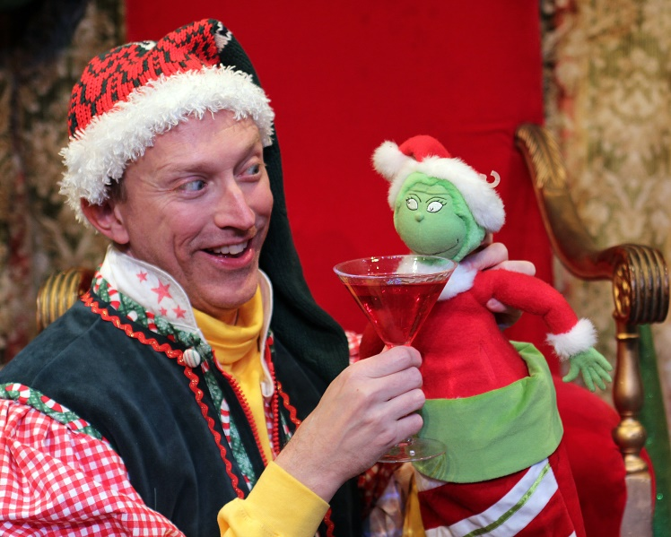
(Mark Stephens as Crumpet the Elf)

Stars veteran area actor Mark Stephens in a one-man riff as an unemployed actor who decides to audition for the part of Crumpet the Elf at Macy’s during the holiday crunch. At first the job is only humiliating, but once thousands of children start pouring through Santa’s Workshop he becomes battle weary and bitter, entertaining us with stories of naughty children and pushy parents, empowered elves and sloshed Santas.

“A delightfully thorny account of working as a Yuletide elf at Macy’s. Priceless observations, both outrageous and subtle. Destined to hold a place in the annals of American humor writing.” -The New York Times.
(suggested for adult audiences)

-- December 6, 7, 8 and 11 thru 15 --
(Fridays & Saturdays at 8 pm, Wednesday & Thursday 7:30 pm, Sundays at 2:30 pm
at the Schenectady Civic Playhouse

12 South Church St. in Schenectady’s historic Stockade District

TICKETS ($17) Purchase in person at Proctors Box Office, 432 State Street, Schenectady. Or order and charge by phone through Proctor’s Box Office at (518) 346-6204. Or order on-line at www.civicplayers.org

