-- OPENS NEXT WEEKEND, JANUARY 24 –

SCHENECTADY CIVIC PLAYERS .
present Steven Dietz’s . . .
SHERLOCK HOLMES:
The Final Adventure
directed by Aaron Holbritter
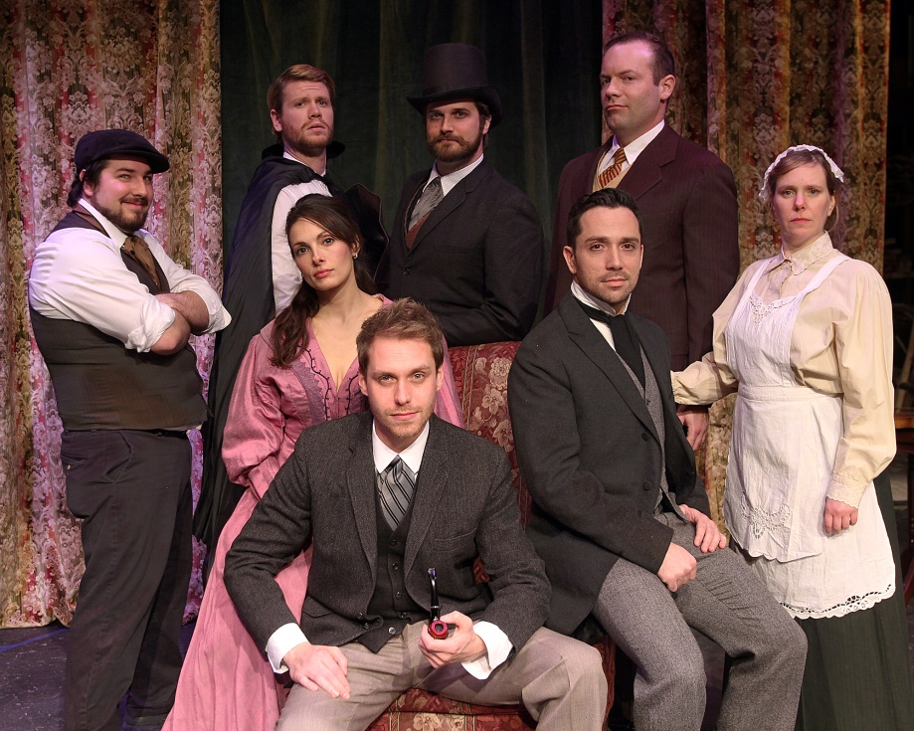Seated (l to r) Erin Waterhouse as Irene Adler, Tom
Templeton as Sherlock, and Ian LaChance as Dr.Watson. Standing (l to r)Chris Guyon as Sid Prince, Dave Cerutti as The King of Bohemia, Isaac Newberry as Moriarty, Marc Destefano as James Larrabee, Amy Lane as Madge Larrabee.

The King of Bohemia is about to be blackmailed by a notorious photograph, and the woman at the heart of this crime is the famous opera singer Irene Adler. With Dr. Watson at his side, Mr. Holmes pursues first the case, and then the affections of Miss Adler…and in doing so marches right into the lair of his longtime adversary, Professor Moriarty.
- January 24-26 and 29 thru Feb. 2 -
(Fridays & Saturdays at 8 pm, Wednesday & Thursday 7:30 pm, Sundays at 2:30 pm
at the Schenectady Civic Playhouse

12 South Church St. in Schenectady’s historic Stockade District

TICKETS ($17) Purchase in person at Proctors Box Office, 432 State Street, Schenectady. Or order and charge by phone through Proctor’s Box Office at (518) 346-6204. Or order on-line at www.civicplayers.org

