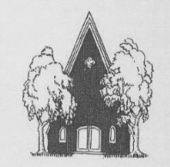 Be our guest Sunday, February 9

Celebrating our 86th Season . . .

Schenectady Civic Players invite you to . . .

A FREE staged reading of . . .

David Berry’s . . . .
The Whales of August
Directed by Chris Howard

The Whales of August, an Off-Broadway success, tells the story of two elderly widowed sisters near the end of their lives, spending a summer in a seaside house in Maine. The surroundings cause them to recall their relationship as young women, and the summers they had enjoyed there in the past. The 1987 film version starred Bette Davis and Lillian Gish as the elderly sisters.
Features Capital District and frequent Schenectady Civic Players actors Melissa Putterman-Hoffmann, Joanne Westervelt, Robert L. Hegeman, Sally Farrell, and Gary Hoffmann.
- Sunday, February 9, at 2:30 p.m. --
(One Performance Only)
at The Schenectady Civic Playhouse
12 South Church St., in Schenectady’s historic Stockade District (518-382-2081)

FREE Admission. Open Seating. No advance reservations.
(Light refreshments served after the show in the Green Room)

We’re your community theater. At the reception ask how you might get more involved in our on-stage and/or back-stage fun and excitement. www.civicplayers.org

