The Theater Project of Schoharie County Presents: “Elm Circle”, written by Mike Casale, a graduate of Lansingburgh High School and SUNY Plattsburgh. Director is Willard Martin and Producer is Ron Cleeve.

In 23 scenes, a 15-year-old troubled teen run-a-way who struggles with reality, goes to New York City.
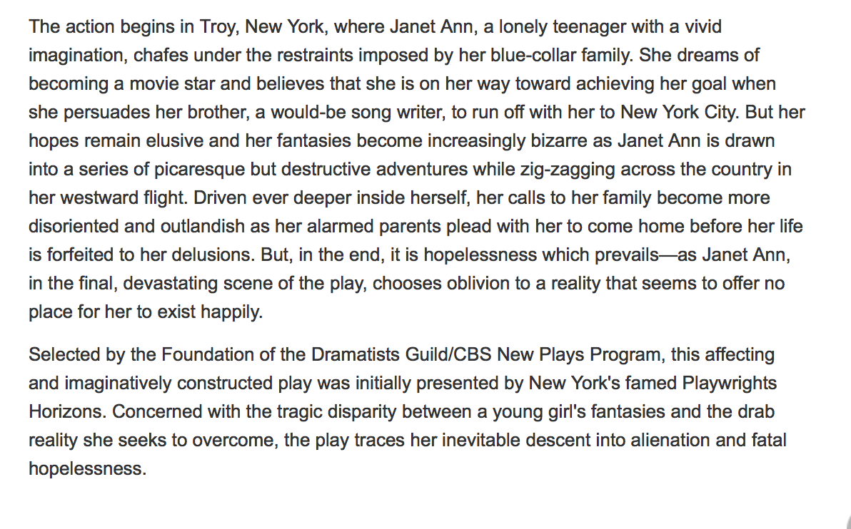
The performance nights will be held at the Golding Auditorium: 7:30 PM Thursday-Saturday, March 27, 28, & 29. A special matinee will be performed on Sunday, March 30 at 2:00 PM. Tickets are $8. for general admission and $6. for Students & Seniors.
Please join us for this thought-provoking production by talented performers: The cast includes: Olivia Galasso as Janet Ann, Sue Peter as the mother, Schuyler Shaw as the father, Sean Jordan as the brother, Drew Martin as the boyfriend, and the pixies.
For more information, contact Willard Martin at 234-4892 or willardm1947@yahoo.com

