OPENING FRIDAY, DECEMBER 5th
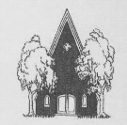SCHENECTADY CIVIC PLAYERS present . . .
“a hilarious, quirky and thrilling alternative to your standard holiday entertainment. . . . the perfect gift for the holidays … a fantastically fun night out at the theatre.”
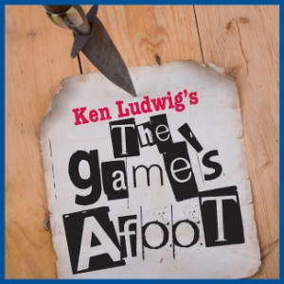 OR HOLMES FOR THE HOLIDAYS
Directed by Debbie May December 5, 6 & 7 and 10 thru 14

(FRIDAYS & SATURDAYS at 8 pm; WEDNESDAY & THURSDAY at 7:30 pm; SUNDAY matinees at 2:30 pm)
From the creator of Lend Me a Tenor comes this whodunit filled with twists, turns and murderous pandemonium. It is December 1936 and Broadway star William Gillette, admired the world over for his leading role in the play Sherlock Holmes, has invited his fellow cast-members to his Connecticut castle for a weekend of revelry. But when one of the guests is stabbed to death, the festivities in this isolated house of tricks and mirrors quickly turn dangerous. Then it’s up to Gillette himself, as he assumes the persona of his beloved Holmes, to track down the killer before the next victim appears. The danger and hilarity are non-stop in this glittering whodunit set during the Christmas holidays.
The Civic Players’ eight character cast features Michael Ciaravella (as William Gillette), Lucy Breyer (as Martha Gillette), Mark Kittel (Felix Geisel), Cara Juras (Madge Geisel), Keith Coombs (Simon Bright), Meigg Jupin (Aggie Wheeler), Nancy Hammell (Inspector Goring) and Melissa Peterson (as Daria Chase).
Tickets, $17. Order in person at, or charge by phone through, Proctors box office 346-6204.
Order on-line at www.civicplayers.org More info call 382-2081.
SCHENECTADY CIVIC PLAYHOUSE (12 South Church St. – Downtown Schenectady – In the historic Stockade district)

