Local Actors Guild of Saratoga
Contact: Chad Radock, Spokesperson,
(978) 376-8178 chadradock@gmail.com
Local Actors Guild of Saratoga Presents:
NEW PLAY FESTIVAL
LOCAL PLAYS BY LOCAL AUTHORS PERFORMED BY LOCAL ACTORS
The Local Actors Guild of Saratoga is proud to present its first ever New Play Festival to be held December 13 and 14, and December 20 and 21 at the Dee Sarno Theater at the Saratoga Arts Center, 320 Broadway, Saratoga Springs. Tickets are $15 for one show, and $30 for all three shows. All proceeds will benefit the Local Actors Guild of Saratoga, and assist with the production of our 2015 season. Tickets can be purchased at the door. For Reservations, please call (518) 393-3496.
This summer, the Local Actors Guild of Saratoga issued a call for original plays from local playwrights. Three were chosen out of 30 scripts that were submitted. Actors have been hard at work rehearsing for weeks at the Arts Center in Saratoga, and the stage is set for our opening weekend. Join us in celebrating the work of these local artists. Including cast and crew of all three shows, about two dozen local actors and theater buffs are involved in LAGS production of these original plays.
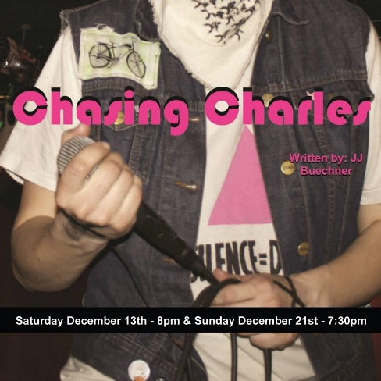
Written by JJ Beuchner, who also serves as Artistic Director and Producer for the Guild, Chasing Charles is a Drama/Comedy based on true life events of Charles Elsen, a professional make up and wig designer. Set against the backdrop of Manhattan from the late 70's to the early 80's. The show follows Charles and his longtime business partner Dennis' friendship and how it stood the test of time through the AIDS crisis. Chasing Charles will run on December 13 at 8pm, and on December 21st at 7:30pm

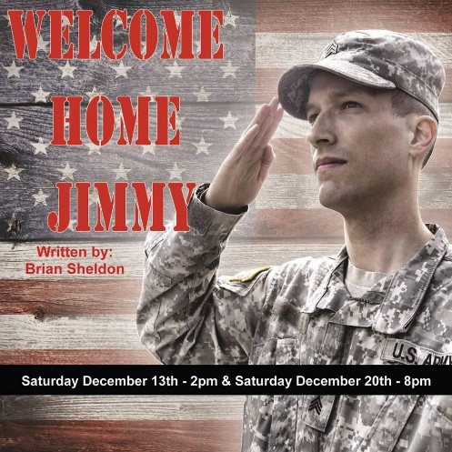
Welcome Home Jimmy was written by Brian Sheldon. After a tour in Afghanistan, Jimmy is returning to his loving, conservative family. The house has been cleaned and decorated; all that’s needed now is Jimmy. As the family arrives and awaits the return of the prodigal son, they agree to keep secret the one thing that could ruin Jimmy’s homecoming and in doing so, begin unearthing other secrets that start tearing at the seams and begin to crush everything these people know about family. Welcome Home Jimmy will run on December 13 at 2pm and December 20th at 8pm.
A veteran LAGS stage manager, Christina Asselin, wrote and is directing Life in 3-D, the story of Ally and her friends, many of whom live on the third floor of her apartment building. The show primarily takes place in Ally’s apartment as she and her friends navigate dating, and friendships at this juncture of their lives. Ally is a self-identified Lesbian. She came out in her early 20’s but has only really ever dated one woman. Six months before the play, Ally’s live-in girlfriend, Jamie, leaves her without an explanation. A major subplot of the story is the interplay between Ally and her mother who is still coming to terms with her daughter’s sexuality. Life in 3-D will run on December 14 at 7:30pm and December 20 at 2pm.

Full list of Cast and Crew Members:

Chasing Charles
Written by: JJ Buechner
Directed by: Hollie Miller
Stage Manager: Steven Moulton
Charles - Matt DeMarco
Dennis - JJ Buechner
Angela - Ann Milliken
Brian - Nathan Hoffmann
Edward - Oliver Ord
Carol - Elizabeth Sterling
Richard/Nurse - Chad Radock
Welcome Home Jimmy
Written by: Brian Sheldon
Directed by: Patrick White
Stage Manager: Nick Himmelwright
Harriet - Patricia Keister
Samantha - Alyssa Stephan
Phil - Kevin Barhydt
Ben - John Massaroni
Kate - Cori Irwin
EMT - Kara DiCaterino
EMT - Ralph Politano
Life in 3D
Written and Directed by: Christina Asselin
Stage Manager: Katherine MacLellan
Ally - Christina Asselin
Dani - Elizabeth Sterling
Ally’s Mom - Darlene Kelly
Elliot - JJ Buechner
Jo - Sheila O’Shea
Reggie - Suzy Chhim-Parisi
###

