HONORS RECITAL
Sponsored by the Eastern New York Chapter
of the National Association of Teachers of Singing

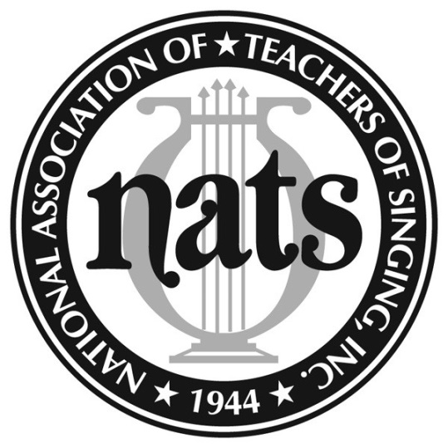

Performers:
Katherine Krebs, soprano Peter Subers, baritone
Justin Gerard, bass-baritone Catie LeCours, soprano
with
Todd Sisley, pianist

Sunday, February 21, 2016
2:00 P.M.
Westminster Presbyterian Church
262 State Street, Albany, NY 12210

Admission is free
Reception follows

