Magical Stage Productions

Present

“CALIFORNIA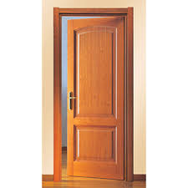 SUITE”
A Comedy by Neil Simon
Directed by Iris Singer

Starring: Debra Bercier, Stephen Tomasik, Susan Dantz, Theodore Zeltner, Myrna Bernsten

WHERE: ST. SOPHIA GREEK CHURCH
WHITEHALL RD, ALBANY, NEW YORK

WHEN: 2/1, 2/2, 2/3 and 2/15, 2/16, 2/17
7:00 PM
Tickets: Adults $20, Students/Seniors $18
Sold at the door or call 518-366-6545 for more information

