FOR IMMEDIATE RELEASE
Contact: Mike Clary, media.greatbarringtonpublic@gmail.com
Elizabeth Nelson elizabethnelson817@gmail.com

May 20, 2022

Great Barrington Public Theater Art Show PERSIST Spotlights Seven Women Artists Working in Different Media, To Reflect Solo Fest Theme ‘Voices of Humanity’.
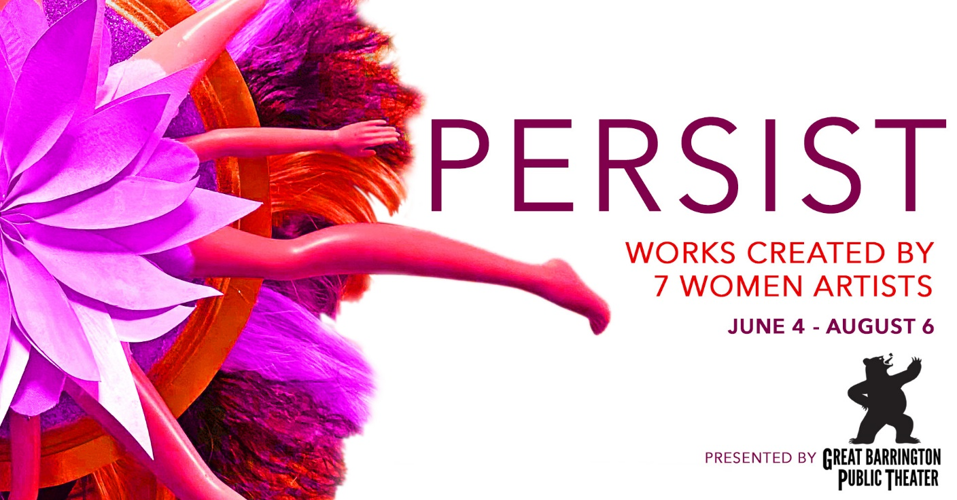

As part of GB Public’s 2022 summer season, in conjunction with the Solo Fest (June 3-July 10), audiences and art lovers are invited to view a collection of gallery works created by seven women artists from around the Berkshires. Organized and curated by GB Public Associate Artist, Elizabeth Nelson, PERSIST explores themes of erosion, trauma, reimagination, investigation, beauty, and violence. The art show is presented as part of the Solo Fest theme of ‘voices of humanity’. There will be a public opening and reception with the artists 5:30-7:00pm, June 17, coinciding with 7:30pm opening of Robin Gerber’s new play, The Shot, which features well-known screen and stage actor Sharon Lawrence as Katharine Graham, famous publisher of The Washington Post, whose persistence in life and career is a model of a woman taking on power.

“Theater is the live, public lyceum. It’s where contemporary culture is expressed and comes to conversation, explains Artistic Director Jim Frangione. “We are in new challenging times, and the Solo Fest is meant to voice a few of the big questions humanity is now asking. When Elizabeth suggested an art show installation in the gallery onsite, it was a natural fit. It’s an extension of some of the same questions the Solo Fest brings to stage. In light of what’s happening all around us in 2022, we all need to persist.”

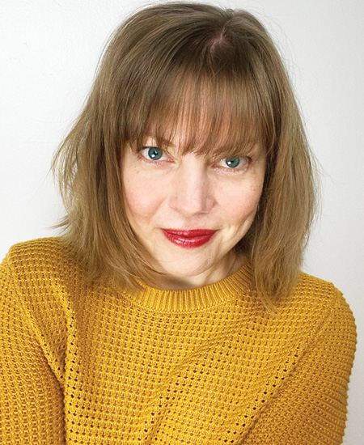
PERSIST curator & GB Public Associate Artist Elizabeth Nelson
“I wanted to bring together women who have been creating during these turbulent times,” Elizabeth Nelson adds. “Creating as a way to process, to maintain purpose and joy—to persist. What I discovered is that we have all been persisting in a multitude of ways from the beginning, as both women and artists. I’m curious how experiencing these particular works together as part of seeing live theater will affect the audience—what stories will reveal themselves? What might the viewer discover about how they have and continue to persist?”

Gallery works will include photography, drawing, flash fiction/CNF, and sculpture using recycled textiles, found and repurposed objects, and natural materials such as wood, bone, clay, and feathers.

PERSIST artists include: Parasrevi "Toula" Taliadoros, owner and artist behind Make My Day Design; Deirdre McKenna, writer and performer with the Powder Keg Writing Group for Women; Merudjina Normil, interdisciplinary artist; Ariana Kolins, interdisciplinary artist; Lindsay Neathawk, owner of Neathawk Designs; Natalia Bystrianyk, intuitive painter; and Elizabeth Nelson, writer, multidisciplinary artist, and marketing professional.
PERSIST will be on view June 4 through August 6, 2022 in the Student Gallery outside the Liebowitz Black Box Theater in the Daniel Arts Center on the campus of Bard College at Simon’s Rock. Public reception is June 17, 5:30pm-7:00pm. More information and artists’ bios and samples can be seen on the company website GreatBarringtonPublicTheater.org.
####

