For Immediate Release
Contact: Mike Clary
MrMikeClary1@gmail.com
518-267-0683

June 12, 2022

Great Barrington Public Theater Solo Fest premieres Leave Your Fears Here, the true story of how a young boy facing life-threatening realities taught his parents the power of hope and courage.

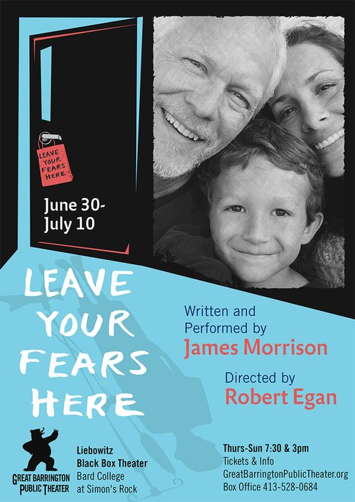

The GB Public Theater 2022 stage season presents four new solo performances over six weeks. All feature stories of humanity and demonstrate the power of a single voice to tell them.

Leave Your Fears Here (June 30 - July 10) is a loving and insightful memoir written and performed by the accomplished and familiar stage and screen actor James Morrison. In a riveting performance that legendary producer Norman Lear called “An extremely moving play by an extremely moving performer”, the well-known actor recounts his
10-year-old son Seamus’s daunting passage from brain cancer diagnosis, through treatment to ultimate recovery, and how he inspired courage and change in others, most notably his father. It’s a profound, heroic story of the power of hope leading to triumph in the darkest hours.

When catastrophic illness strikes suddenly, lives are rudderless. When their son all at once faced numerous physical debilities and a life-threatening diagnosis, Morrison, his wife and family had to face reality and mortality while simultaneously navigating the labyrinth of 21st century life and medical processes. They and other adults found themselves transcended by their son’s courage, innate wisdom and ability to face and accept harrowing experience with truth, strength, humor and poetic nature.

Directed by Robert Egan, Leave Your Fears Here was incubated, developed and first staged at the nationally renowned and multi-award-winning Ojai Playwrights Conference, where Robert has been Artistic Director since 2002. Egan says, “I first met James when he played Brick in Cat On a Hot Tin Roof for the legendary Jose Quintero in 1983. I knew I was in the presence of a rare acting talent -- truthful, raw, powerful and magnetically real. Cut to 35 years later and James gives me an equally passionate and poignant theatrical account of his son’s courageous journey surviving a brain tumor. We live in an extraordinary time where our country is facing historic battles with health issues. This deeply personal work immerses us into a new way of learning, listening and advocating for our loved ones battling to live with love and connection.”

Audiences will recognize James Morrison from 24, Law and Order SVU, The West Wing, Six Feet Under, Twin Peaks: The Return and other series and movies. “It’s more than just a story about a boy who had brain cancer,” he says. “It’s about each of us walking into unknown, frightening places, realizing our untapped strengths and powers, and learning how to bring courage to life, even when the lesson is being taught by your child. Theatre is my medium, it’s where I started as an actor 50 years ago, and along with being Seamus’s father, I’ve always felt it was what I was put here to do, so it only seems natural to bring my story to the stage. If making our journey public allows one person to feel hope or gratitude as they navigate, battle and conquer their fears, I’ve succeeded beyond measure.”

Leave Your Fears Here closes the four-part Solo Fest and will be staged ten times only, from June 30-July 10, Thurs.-Sun., 7:30pm and 3pm, in the Liebowitz Black Box Theater, Bard College at Simon’s Rock, 84 Alford Rd, Great Barrington, MA 01230. Advance tickets are encouraged and can be made on the Great Barrington Public Theater website.
###
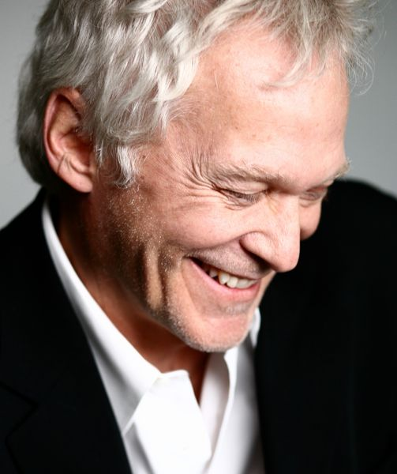
Actor James Morrison/credit Zaugh photography
James Morrison has played hundreds of roles on stage, film and television in the last 45
years, most notably on 24 as Bill Buchanan and Twin Peaks: The Return. For his work onstage he received the Los Angeles Drama Critics Circle Award and appeared at the Mark Taper Forum, McCarter Theatre, the Old Globe, La Jolla Playhouse, London’s Donmar Warehouse and Riverside Studios, and the Alaska Repertory Theatre (in his hometown of Anchorage) where he served his apprenticeship. As a filmmaker,
James co-produced/directed the documentary, Showing Up: A Conversation About the Audition with his wife, Riad Galayini.
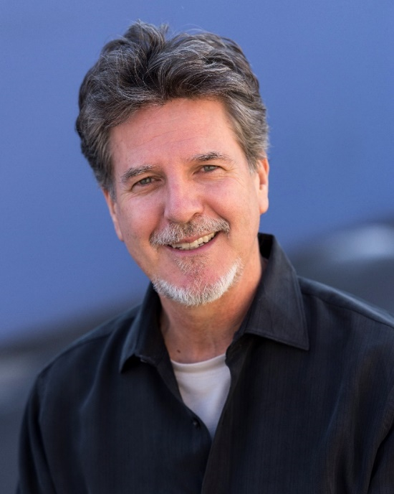
Director Robert Egan/ credit GBPT
Robert Egan is an award-winning producer and director who has served as the Artistic Director/Producer of the Ojai Playwrights Conference since 2002. Prior to OPC, Robert served for 20 years as the Producing Artistic Director at the Mark Taper Forum where he was Director of New Play Development and the Founder and Producing Artistic Director of its prestigious New Work Festival. He was also the Associate Artistic Director of the Seattle Repertory Theatre where he created their new play development program. Robert has produced, directed, and dramaturged hundreds of new plays in the United States and Europe.
Robert is also the Founder and President of RHEgan Productions, LLC where he conceives, writes, produces and directs major live events and media projects for non-profits including Cure Autism Now, Operation Smile, L.A,, Team Mentoring, Global Green USA Homeboy Industries, Center Theatre Group and UCLA.

Great Barrington Public Theater was founded by Artistic Director Jim Frangione and Executive Director Deann Simmons Halper to create opportunities for theater artists in the Berkshires and neighboring regions. Great Barrington Public Theater recognizes the many excellent playwrights, actors, directors, designers, administrators and technicians living in the Berkshires and surrounding areas. Our objective is to bring a mix of new and contemporary plays to the stage in a variety of formats; to generate and foster creative and rigorous opportunity for local theater artists, while engaging our theatergoing public with new and contemporary readings, workshops, and fully staged productions, involving local talent as often as possible, and always keeping ticket prices affordable.

