For Immediate Release
Contact: Mike Clary
MrMikeClary1@gmail.com
518-267-0683

June 27, 2022

Leave Your Fears Here, a story of hope, bravery, family love and survival in the face of childhood cancer. Onstage June 30-July 10 at Great Barrington Public Theater.

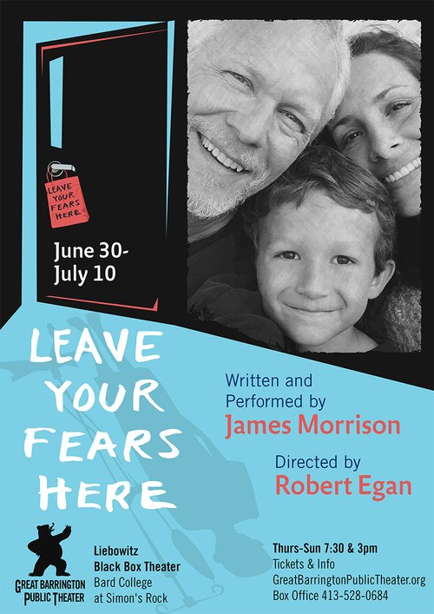

The GB Public Theater 2022 four-title Solo Fest concludes with Leave Your Fears Here (June 30 - July 10), a loving memoir written and performed by accomplished stage and screen actor James Morrison. In a touching performance that legendary producer Norman Lear called “An extremely moving play by an extremely moving performer”, the actor recounts his 10-year-old son Seamus’s brain cancer diagnosis through treatment to recovery, and how he brought courage and change in others, most notably his father. It’s a heroic poetic expression of the power of hope and triumph in the darkest hours.

When Seamus suddenly faced physical debilities and a life-threatening diagnosis, Morrison, his wife and family had to face hard reality while simultaneously navigating the daunting medical processes. They found themselves transcended by Seamus’s courage, brightness and ability to face his harrowing experiences with strength, humor and poetic nature.

Directed by Robert Egan, Leave Your Fears Here was developed and first staged at the multi-award-winning Ojai Playwrights Conference, where Egan has been Artistic Director since 2002

Audiences will recognize James Morrison from 24, Law and Order SVU, The West Wing, Six Feet Under, Twin Peaks: The Return and other series and movies. He notes, “If making our journey public allows one person to feel hope or gratitude as they navigate, battle and conquer their fears, I’ve succeeded beyond measure.”

Leave Your Fears Here will be staged ten times only, from June 30-July 10, Thurs.-Sun., 7:30pm and 3pm, in the Liebowitz Black Box Theater, Bard College at Simon’s Rock, 84 Alford Rd, Great Barrington, MA 01230. Advance tickets are encouraged and can be made on the Great Barrington Public Theater website.
###
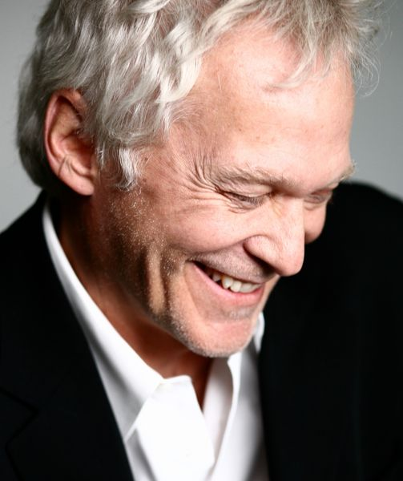
Actor James Morrison/credit Zaugh photography
James Morrison has played hundreds of roles on stage, film and television in the last 45
years, most notably on 24 as Bill Buchanan and Twin Peaks: The Return. For his work onstage he received the Los Angeles Drama Critics Circle Award and appeared at the Mark Taper Forum, McCarter Theatre, the Old Globe, La Jolla Playhouse, London’s Donmar Warehouse and Riverside Studios, and the Alaska Repertory Theatre (in his hometown of Anchorage) where he served his apprenticeship. As a filmmaker,
James co-produced/directed the documentary, Showing Up: A Conversation About the Audition with his wife, Riad Galayini.
###

Great Barrington Public Theater was founded by Artistic Director Jim Frangione and Executive Director Deann Simmons Halper to create opportunities for theater artists in the Berkshires and neighboring regions. Great Barrington Public Theater recognizes the many excellent playwrights, actors, directors, designers, administrators and technicians living in the Berkshires and surrounding areas. Our objective is to bring a mix of new and contemporary plays to the stage in a variety of formats; to generate and foster creative and rigorous opportunity for local theater artists, while engaging our theatergoing public with new and contemporary readings, workshops, and fully staged productions, involving local talent as often as possible, and always keeping ticket prices affordable.

