For Immediate Release
Contact: Mike Clary
MrMikeClary1@gmail.com
518-267-0683

July 6, 2022

Mark St. Germain’s brand-new comedy Public Speaking 101 premieres July 14 at Great Barrington Public Theater, for anyone who ever said, “I wish I said..”

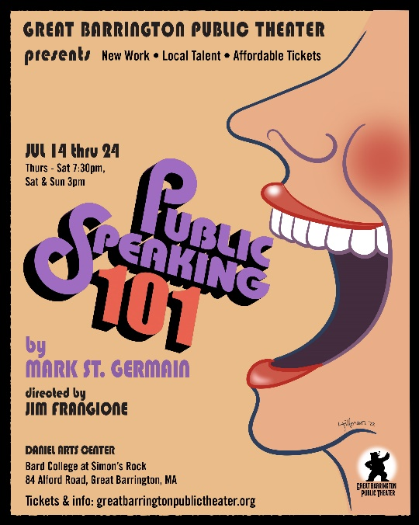

The GB Public Theater 2022 mainstage opens with Public Speaking 101 (July 14 - July 24) a fun, turn-the-tables comedy by the much loved, wonderfully accomplished and always engaging Berkshire-based playwright Mark St. Germain.

When a neurotic, amateur actress leads her community college class of terrified adults to compete in their county’s First Annual Public Speaking Competition, their cross-currents, tongue-tied quirks and foibles become a tight, repartee comedy, brought to life by a brilliant cast, including Peggy Pharr-Wilson, David Smilow, Nathan Hinton, Brendan Powers and Rachel Burttram. Directed by GBPT Artistic Director Jim Frangione, Public Speaking 101 brings the misfit contest and heartfelt laughter to the McConnell Theater for ten performances only.

Audiences know and love Mark St. Germain’s quick, sharp dialogue and knotty situations where characters walk into quicksand of their own making and need to reach out to others for a lifeline. “Mark is a master at comic set-up, timing and real character quirks,” director Jim Frangione says. “He can come up with a very funny storyline, and no one gets out until the hang-ups are resolved. This time, Mark gives us a comedy with great heart. Speaking in public is number one phobia for almost everybody. For these people it’s absolute terror. We all know the moment, when we wish we would have said something but couldn’t find the words.” Frangione works closely with St. Germain and directed and played the title role in GBPT’s 2021 production of Mark’s comedy Dad. “It becomes more than a comic story about a classroom of mixed nuts and lost dogs. It’s about finding that sweet spot in your heart that lets you pump yourself up and show yourself off as the prize-winner we all know we are, no matter what. Mark has given us a feel-good story just when the world really needs one.”

As St. Germain explains it, “We have a pastor terrified of addressing his congregation and sings to them instead, a cop who dissolves on the witness stand, a mortician more comfortable with the dead than the living and a writer whose every word sounds like drying paint, taught by Sunny Strutt, an aspiring community theater actress whose offstage life is falling apart. It takes us into the hearts of a misfit class struggling to find their own voices.”

Mark St. Germain, Jim Frangione and Public Speaking 101 cast members are available for interviews.

Public Speaking 101 and will be staged ten times only, from July 14-July 24, Thurs.-Sun., 3pm and 7:30pm, in the McConnell Mainstage Theater, Daniel Arts Center, Bard College at Simon’s Rock, 84 Alford Rd, Great Barrington, MA 01230. Tickets can be reserved on the Great Barrington Public Theater website.
###

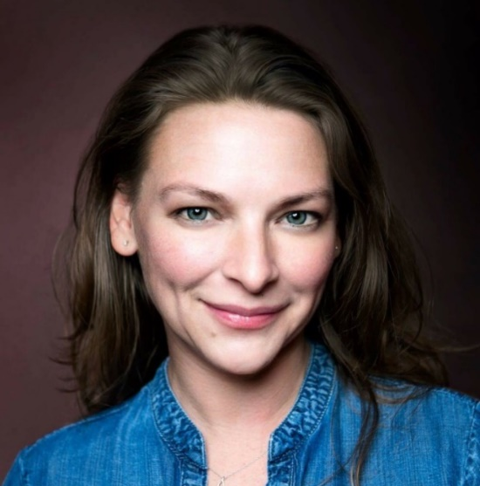
Rachel Burttram as Millie Harrow
Rachel Burttram* (Millie Harrow) is thrilled to be in beautiful western Massachusetts with this amazing team of artists this summer! NYC credits: Actors’ Studio, Vital Theatre Company. Regional credits: Geva Theatre Center, Kitchen Theatre Company, Gloucester Stage Company, Riverside Theatre, Actors’ Theatre of Louisville, Penobscot Theatre Company, Florida Repertory Theater, The Hippodrome. Online: Alabama Shakespeare Festival @Home 2020, tiny_Theatre. TV/Film: The Right Stuff on Disney+ as Betty Grissom, Emma’s Fine as Emma. Co-creator of tiny_Theatre along with her remarkable husband, Brendan Powers. BIG Thanks to Jim, Mark & the folks at GBPT for the warm welcome! www.RachelBurttram.com www.tiny-theatre.com

Nathan Hinton as Rev. Montavius Lester

Nathan Hinton* (Reverend Montavius Lester) has performed at some of the most respected and emerging theater companies in the country. He began his career at Joseph Papp’s Public Theater and in 2017 realized a personal dream by playing Zachariah in Athol Fugard’s Blood Knot at the Mosaic Theater Co., directed by Joy Zinoman. He played Memphis in Two Trains Running (Triad Stage) and Jon in Marjorie Prime (Pittsburgh Public Theater). He appeared in the world premiere of Jeff Augustin's Where the Mountain Meets the Sea at Actors Theatre of Louisville. He has performed at Shakespeare Theatre Co., Berkeley Repertory Theatre, Dallas Theatre Center, and Huntington Theatre. He was in the first national touring company of Angels in America, won the Barrymore Award for Take Me Out at Philadelphia Theatre Co., and received an Audelco Award nomination for Living in the Wind at American Place Theatre. Television credits include The Equalizer, FBI: Most Wanted, Manifest, and Madam Secretary. He is a member of Actors’ Equity, the Screen Actors Guild, and The Actors Center.

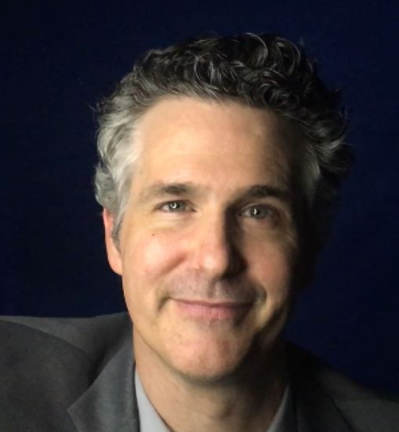
Brendan Powers as Fletcher Tuft
Brendan Powers* (Fletcher Tuft) Regional theatre credits include Boston Theatre Marathon, Gloucester Stage, North Shore Music Theatre, Penobscot Theatre, Seacoast Rep, Hangar Theatre, Kitchen Theatre, and Florida Repertory Theatre. Recent roles include Sam Phillips in Million Dollar Quartet, Torvald in A Doll’s House Part 2, Phileas Fogg in Around the World in 80 Days, Anthony in Outside Mullingar, Alan in God of Carnage, and the Stage Manager in Our Town. In 2020 he and his wife, Rachel Burttram, turned a bedroom closet into a tiny theatre (www.tiny-theatre.com) and landed a feature article in American Theatre Magazine. Thanks Jim, Mark, GBPT and all who support the arts!

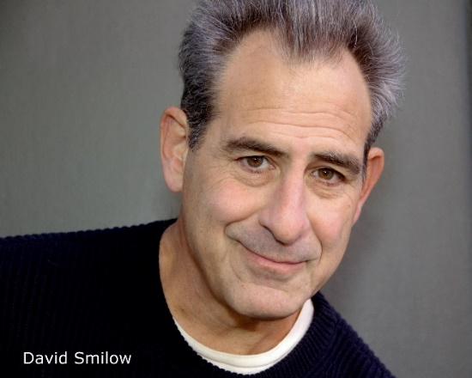
David Smilow as Sgt. Mike Gallion
David Smilow (Sergeant Mike Gallion) is fortunate to be appearing in his third premiere of a Mark St. Germain play, having performed in Dad last season at GBPT and Wednesday’s Child a few seasons back (a lifetime bordering on eternity in COVID-19 terms) at the Florida Studio Theatre in Sarasota. A relatively recent arrival to acting after a long writing career, he’s taken on roles ranging from Heisenberg in Copenhagen, to Serebriakov in Uncle Vanya, Orgon in Tartuffe, and the besieged college professor, John, in David Mamet’s Oleanna. David has also played another species onstage—specifically Canus—having appeared as a dog in two different plays. As a writer, his work earned him multiple Emmy and Writers Guild awards during stints on such venerable (and now departed) shows as One Life to Live, Guiding Light, and As the World Turns. David lives in the Hudson Valley, having survived residency in both Los Angeles and New York City.

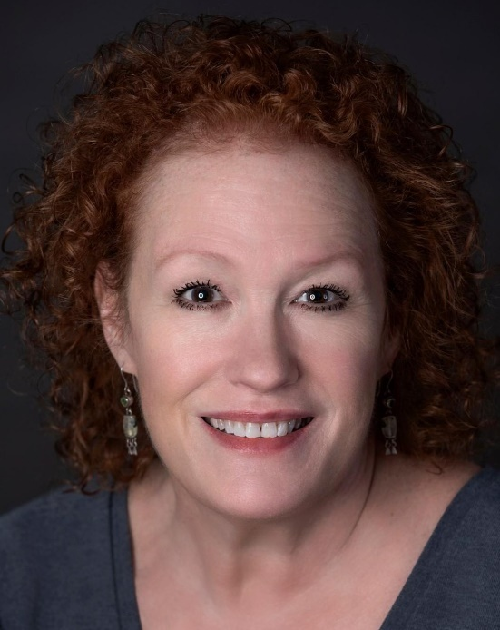
Peggy Pharr-Wilson as Sunny Strutt
Peggy Pharr Wilson* (Sunny Strutt) GBPT: Dad. Barrington Stage Co: (Associate Artist) Boca, America v2.1, Gas Light, His Girl Friday, The Crucible, To Kill A Mockingbird, Guys & Dolls, Carousel, Laramie Project: Epilogue, 10x10 new play festival (2012-2022). BAT: Aloyisius in Doubt (nominated best actress Broadway world). Shakespeare & Co: Leap Year. New York: Six Women with Brain Death (co-author, and performed it also in Chicago, Dallas & Kansas City). Regional: 10 seasons with Creede Repertory Theatre in Colorado performing over 50 roles, including Mrs. Lovett in Sweeney Todd (best actress Ovation Award Denver Post), Shirley Valentine, Josie in Moon for The Misbegotten and Mac in 3 Viewings. Several readings at BPL. Many other regional including: Dallas Theatre Center, Theatre 3, Kansas City Rep, Unicorn, KC Lyric Opera, White River in Vermont and Rose Theatre in Chicago. Married to managing director Tristan Wilson.

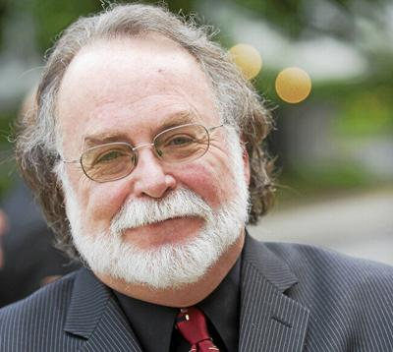
Playwright Mark St. Germain
Mark St. Germain's new comedy DAD was staged in 2021 at Great Barrington Public Theater. His short movie THE REJECT was featured in Berkshire Outdoor Shorts, produced by Great Barrington Public Theater and the Berkshire Film & Media Collaborative. His play ELEANOR, about Eleanor Roosevelt, premiered in 2021at Barrington Stage Company, followed soon thereafter by another new work, CROSSING-A DANCE MUSICAL. He also wrote the plays FREUD’S LAST SESSION (Off Broadway Alliance Award), CAMPING WITH HENRY AND TOM (Outer Critics Circle Award and Lucille Lortel Award) FORGIVING TYPHOID MARY, (Time Magazine’s “Year’s Ten Best”) and BECOMING DR. RUTH. With Randy Courts, they have written the musicals GIFTS OF THE MAGI, JOHNNY PYE and JACK’S HOLIDAY. With John Markus he wrote THE FABULOUS LIPITONES. Mark co-wrote the screenplay for Carroll Ballard’s Warner Brothers film, DUMA. He directed and co-produced the documentary, MY DOG, An Unconditional Love Story, featuring Richard Gere, Glenn Close and Billy Collins, among others. Mark is an Associate Artist at the Barrington Stage Company. In 2010, Barrington Stage named their second stage “The St. Germain Stage.” His play FREUD’S LAST SESSION will soon be a film, starring Anthony Hopkins, and a screen adaption of his play THE GOD COMMITTEE starring Kelsey Grammer and Julia Stiles can be seen on Netflix.
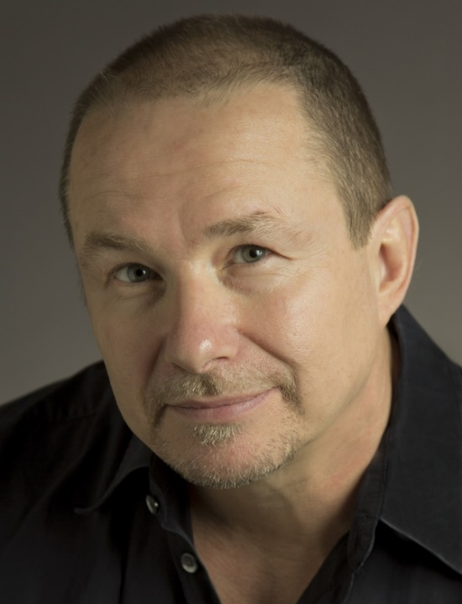
Director Jim Frangione (GBPT Artistic Director)
Jim Frangione (Director)) Last summer with the Public, Jim directed Mark St. Germain’s new play, Dad, as well as the East Coast premiere of David Mamet’s, The Christopher Boy’s Communion. He directed Anne Undeland’s play, Lady Randy, for WAM Theatre; Romance at Wellfleet Harbor Actors Theater; Private Life at HERE Arts in NY; and An Evening of Shorts by Mamet, Pinter and Silverstein at the ART/Harvard Institute for Advanced Theatre Training. Jim’s play, Flight of the Monarch, premiered at Gloucester Stage Company in 2017. His play, Breakwater, the second in a trilogy of Cape Cod plays, received its premiere in 2019 as part of Great Barrington Public’s inaugural season (Berkshire Theatre Critic’s Nomination). Jim has acted for over 35 years; On and Off-Broadway, in National Tours; in many plays with the Atlantic Theater Company and at regional theaters such as: The Mark Taper Forum, Long Wharf, The Alley Theater, Berkshire Theatre Festival, The Humana Festival of New Plays—most recently in Prairie Du Chien at Atlantic and Vanya and Sonia and Masha and Spike at Shakespeare & Company. Films: Joy, Transamerica, Spartan, Heist, State and Main, The Spanish Prisoner, Homicide, Suits, Claire Dolan and Maryam.

Great Barrington Public Theater was founded by Artistic Director Jim Frangione and Executive Director Deann Simmons Halper to create opportunities for theater artists in the Berkshires and neighboring regions. Great Barrington Public Theater recognizes the many excellent playwrights, actors, directors, designers, administrators and technicians living in the Berkshires and surrounding areas. Our objective is to bring a mix of new and contemporary plays to the stage in a variety of formats; to generate and foster creative and rigorous opportunity for local theater artists, while engaging our theatergoing public with new and contemporary readings, workshops, and fully staged productions, involving local talent as often as possible, and always keeping ticket prices affordable.

