For Immediate Release
Contact: Mike Clary
MrMikeClary1@gmail.com
518-267-0683

March 6, 2023

Great Barrington Public Theater to present three outstanding new plays on two stages, in performance June to August.
Lineup includes The Stones, a mind-twisting gothic mystery; Off Peak a sparkling comedy; Just Another Day, a comic and poetic reaffirmation of endless love.

This summer, June to August, Great Barrington Public Theater will produce a trio of new plays featuring top-tier performers, directors and stage artists residing in and around the Berkshires. Performances are in the Daniel Arts Center, Bard College at Simon’s Rock, five minutes from the center of Great Barrington, and, in keeping with GBPT core mission, tickets are affordable to all.

The Public’s ten-week season opens in the intimate Liebowitz black box theater, with the American premiere of The Stones (June 14 to July 2).

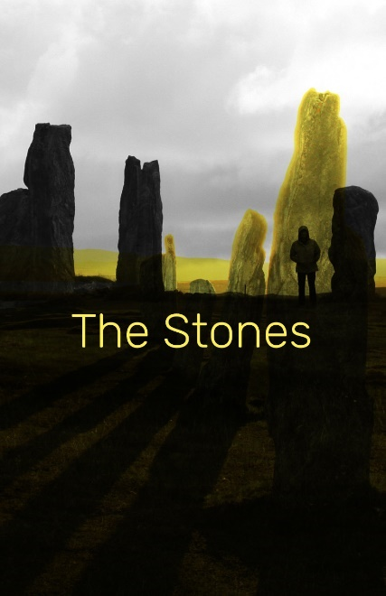
A hypnotic solo show, The Stones is a contemporary gothic mystery by award-winning, London-based playwright/director Kit Brookman It was an audience favorite at the 2022 Edinburgh Fringe Festival.
The story unfolds after Nick quits his teaching job and breaks up with a long-term boyfriend, then hears from an old flame from high school from whom he's withheld a terrible secret. This leads Nick to take a job as a tutor to two young children in the countryside; the job, setting and family seem too good to be true… until the mysterious stones begin to arrive. A gripping, fascinating mystery unfolds. Reality splinters into historical illusions that question whom among us is delusional and who is guilty for humankind’s collective past, present and murky future.
Brookman is a daring, gifted writer from Australia now making a name in British theater circles. Audiences can learn more about Kit Brookman and the play on his website. The Stones will be directed by accomplished actor-director-writer Michelle Joyner, who notes, “It’s a very of-the-moment tale that makes you want to pull your chair closer to the fire and listen. The pacing is tense, the mood darkly comic and spellbinding.”
In choosing The Stones GBPT Artistic Director Jim Frangione says, “We’re thrilled to have the opportunity to present the U.S. premiere of Kit Brookman’s play following its success at last year’s Edinburgh Fringe. It’s a transfixing work by a bold voice and fantastic fit for the Liebowitz black box and our creative teams. Being a powerful writer and storyteller herself. Michelle Joyner is the pitch-perfect director for this postmodern tale.”

Next stop Off Peak (July 6-July 23), on the McConnell Theater mainstage.

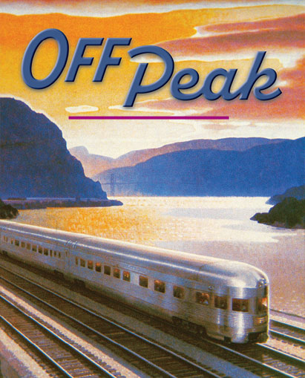
It’s a nimble, funny and at moments poignant new script by writer-actor Brenda Withers that premiered last year, delighting audiences, at the Hudson Stage Company, in nearby Armonk, NY. This was followed by a brief run at Manhattan’s 59E59 Theaters where it gained added positive notice. Brenda Withers describes this work as, “A delightful new play about forgiving, forgetting, and the healing power of a good delay.” The New Yorker called it a “sly, smart, often very funny. Withers’s script providing an abundance of emotional and intellectual twists and turns” and The New York Times said it is “so close to life that you expect a conductor to come in at any second.”

“Off Peak is a smart, repartee comedy that our audiences will enjoy tremendously,” Jim Frangione says. “It’s a cleverly disguised life lesson that invites us to eavesdrop, for a fast-moving 80 minutes, on a man and woman who were once intimately connected and who now find themselves the only two passengers in a Metro North train car. It’s lots of fun, with incisive writing about the difference between love and relationships, the opportunity for second chances, and of course, improbable coincidence and happenstance that make and break relationships. Love is funny stuff. Especially in hindsight.”

Off Peak will feature GBPT favorites Peggy Pharr Wilson and Kevin O’Rourke, directed by James Warwick, who says, “It’s about two richly created, recognizable people who find themselves revealing their past and present, and discovering reconciliation and forgiveness with great humor and compassion. Their stories are told with personal, heartwarming insight.”
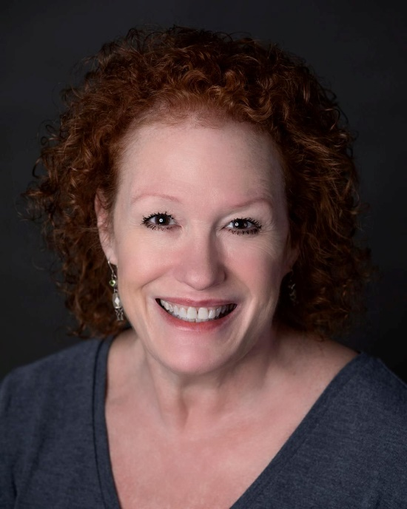
Peggy Pharr Wilson
Kevin O'Rourke

The GBPT summer peaks with Just Another Day, (July 27-Aug 13)
Premiering in partnership with Shadowland Stages in Ellenville, NY, Just Another Day is a heart-stirring new drama by the familiar screen and stage actor-writer Dan Lauria. An aging comedy writer and poet meet daily on a park bench to question the reasons, circumstance, how, why and whether they were ever actually married, and if so, what magic held them together besides a mutual love of old movies.

“Most plays about elderly couples are about younger members of the family,” Lauria said. “But on this bench there are no children, no doctors, no nurses, just two people who trade wit, barbs and nostalgia about old movies, all the while, trying to remember who they are and how they connect, at least for that day. The heart of the story is about respecting the wisdom and the knowledge of our older artists who are being forgotten.”

Frangione adds, “Dan has written an affecting play about endless love, how unreasonable and confusing it is, but lifelong and irrefutable. We become involved with these two strangers, and it will register with anyone who lives with memories of love. We’re very excited to partner and premiere this play with Shadowland Stages.”

Just Another Day will be directed by James Glossman, who says, “How does enduring love speak? Maybe with poetry, but maybe even better with some jokes. Dan Lauria has written a joyous, powerful love story about the lasting gifts of comedy and laughter, even at the end of the world.”

Dan Lauria

‘
Coming August 24-26 Representation and How to Get It
A Special Event
Three Performances Only, at The Mount, Edith Wharton’s home, in Lenox, MA
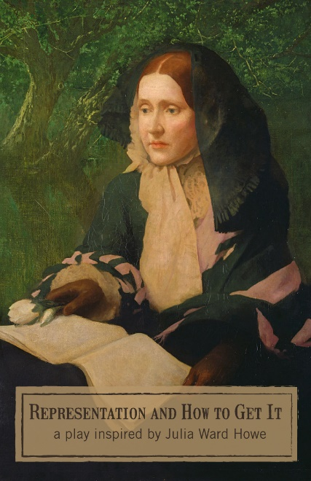
Representation and How to Get It (August 24-26) is a new solo show presented by GBPT in partnership with The Mount, created collaboratively by playwright Joyce Van Dyke, actor Elaine Vaan Hogue, and director Judy Braha.

Poet and visionary Julia Ward Howe, who wrote the Battle Hymn of the Republic, was famous as a charismatic human rights activist. In Representation and How to Get It, it’s early dawn, and we find Julia Howe rehearsing a talk she’s about to give to the Boston Radical Club on political representation for women. She has pointed questions for her audience, delivering a passionate, moving call-to-arms for our time. Director Judy Braha says, “When it comes to speaking truth to power, Julia Ward Howard got it right a century and a half ago. We want her words and this play to charge the audience with agency, hope, and a collective sense of the need to take action now.”

“It’s going to be an all-around fantastic season,” Deann Simmons Halper, GBPT Executive Director sums up the season. “We’re looking forward to sharing four outstanding new plays with theater lovers in the Berkshires, and those who visit from Boston, the Hudson Valley, New York City, and elsewhere. We’re committed to showcasing new plays and to spotlighting the wealth of talent now living in an around the Berkshires. We love to bring new stories and new ways of seeing the world to audiences, and these four plays do it brilliantly.”
On June 9, a Peek Behind the Curtains Benefit at St. James Church, Great Barrington will preview snippets of the GBPT’s coming season as well as new shows being considered for future staging. More details are coming soon. The benefit will include food and drink, live music, singing and other surprise entertainments, as well as meet and greets with some cast members and special company friends. The coming weeks will also see readings of new plays currently in the works at Berkshire Voices.

The Liebowitz and McConnell Theaters are in the Daniel Arts Center, five minutes from downtown Great Barrington on the bucolic campus of Bard College at Simon’s Rock, 84 Alford Road, Great Barrington, MA 01230. More information can be found on the GBPT website and on Facebook. Tickets are affordable to all, between $25 and $50, and are available on the website and by phone 413-372-1980, or GBPTboxoffice@gmail.com.

#####

