For Immediate Release
Contact: Mike Clary
MrMikeClary1@gmail.com
518-267-0683

May 30, 2023

Great Barrington Public Theater set to stage the American premiere of The Stones, a mind-twisting gothic mystery, with Ryan Winkles in a solo performance as the haunted school teacher Nick, directed by Michelle Joyner.

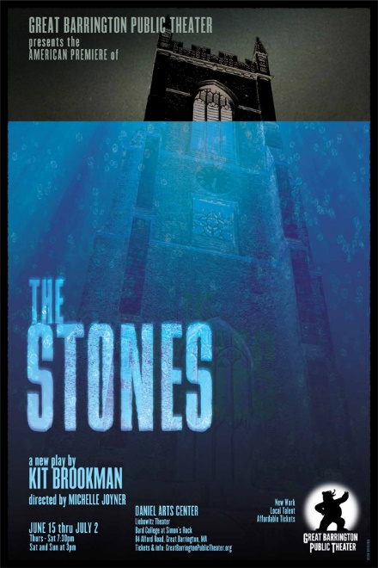

An audience favorite at the 2022 Edinburgh Festival Fringe, The Stones is a present-day, provocative gothic mystery by award-winning, London-based playwright/director Kit Brookman. Great Barrington Public Theater opens the company’s ten-week summer season with the American premiere of the riveting new play.

After a strange epiphany, Nick leaves his job as a school teacher and breaks up with his long-term boyfriend. A reconnection with an old flame-- from whom he's kept a long-buried secret--leads to a job at a countryside estate as tutor to two beguiling young children. In his uprooted situation, the job, setting and family seem too good to be true... until ordinary stones begin to materialize around him. A fascinating, ominous mystery unfolds. Reality splinters into historical illusions with the stones as witnesses of the human record, leaving Nick and his audience to riddle: Who among us is deluded and anesthetized by modern contentment? Who is crippled by guilt and revenge--both personal and collective? And finally: How do we navigate and survive our murky, threatened future?

Brookman is a daring, gifted writer making a name in British theater circles. The GB Public’s production of The Stones pairs Ryan Winkles, one of the Berkshires’ finest actors, with consummate storytelling director Michelle Joyner, who saw The Stones at the 2022 Edinburgh festival. She was taken by the story’s contemporary voice, sensibilities and moody atmosphere and describes it as, “A very of-the-moment tale that makes you want to pull your chair closer to the fire and listen. The pacing is tense, the mood darkly comic and spellbinding.”

Michelle and Ryan are available to interview.

The Stones plays June 15-July 2, Thurs.- Sat., 7:30pm, Sat. and Sun., 3pm, in the Liebowitz black box theater, Daniel Arts Center, Bard College at Simon’s Rock, 84 Alford Road, Great Barrington, MA 01230. More information can be found on the GBPT website and on Facebook. Tickets to performances are affordable to all, between $25 and $50, and are available on the website and by phone 413-372-1980, or GBPTboxoffice@gmail.com.
####

Artist Credits and Bios:

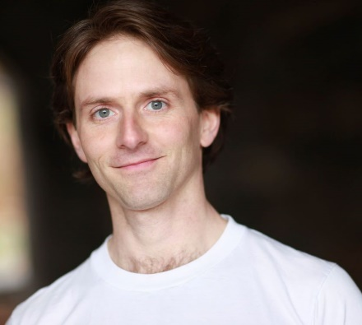
Ryan Winkles
Ryan Winkles- previous shows at Great Barrington Public Theater: Breakwater; Regional credits include: Joy and Pandemic (Huntington Theatre Company); Universe Rushing Apart (Commonwealth Shakespeare); Mr Fullerton Between the Sheets (Gloucester Stage); Visitors (Martha's Vineyard Playhouse); Pericles (the rig); ROE (WAM Theater) Ryan is also a company member of Shakespeare & Company where credits include As You Like It, The Tempest, Henry V, King Lear, Macbeth, Two Gentlemen of Verona, Othello, and Richard III. Television: "Time Traveling Bong"(Comedy Central). Film: The Boston Strangler(Hulu), Paper Birds(French Press Films), UFOTOG(Trumbull Studios). Education: BA, FSU; MFA UW-Madison. Proud member of Actors' Equity and SAG. ryanwinkles.com

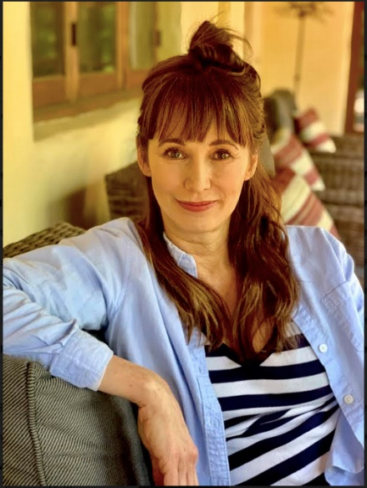
Michelle Joyner
Last season at GBPT, Michelle was the director/dramaturg of The Shot by Robin Gerber, starring Sharon Lawrence, which went on to The United Solo Festival (Theater Row, New York) and won Best Production, Best Performance, Audience Favorite and Best design. It was produced at New Jersey Rep in April 2023. Michelle was Assoc. Director (with Tina Packer) on The Waverly Gallery at Shakespeare and Co. and directed When We Were Young and Unafraid and A Certain Age at their winter reading series, as well as the past three productions of The Valentine Show (with Allyn Burrows). She has directed numerous readings for GBPT and Berkshire Voices as well as many plays on the west coast. This past season she performed an original piece in She/Her at The Edinburgh Fringe Festival, as well as at PS21 in Chatham. She starred in The Approach last season at Shakespeare and Co. (Nomination: Best Acting Ensemble). Michelle is also an accomplished screen actor with a long career and has written ten studio screenplays. Her first full-length play Iodine will have a reading this year. She has directed a short film Especially Not Roommates and leads The Long Table, a women’s writing group. Member: SAG-AFTRA, AEA, WGA, and DG. She is currently creating THE RAMSDELL PROJECT, a theatrical development space in Great Barrington to open later this year.

Director Michelle Joyner and actor Ryan Winkles sit down for their quick take on The Stones.

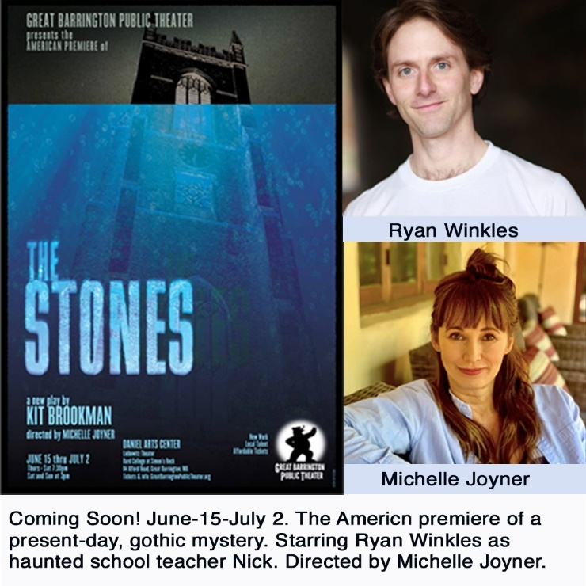

You both see and know plenty of theater. What drew you to The Stones?

Michelle: I saw The Stones at the Edinburgh Festival, where I was performing last summer. We were both in the Assembly Rooms, and I was searching out shows that seemed spooky or scary as research on a play that I'd just finished writing. The Stones is the story of Nick, a teacher going through a personal crisis who reluctantly takes a job on a large estate in the countryside, tutoring two young children. A mystery slowly unravels.
This play succeeds in ratcheting up tension very subtly, but I felt myself and the audience leaning in, as though listening to an eerie story around a campfire. At that point, I had no idea that it would be my next directing project. I was seeing multiple shows a day, as well as performing an original piece, so it was all quite hectic. I bought the play after the show, tucked it away, but found that I kept thinking about the story. It is rather oblique, which I always find compelling. What exactly happened in this play, to this character? Is it a ghost story? How can the mystery be sorted out? I later took the play out and read it, searching for clues. I'm not one who likes spoon-fed entertainment. I want to parse and ruminate. The Stones is unnerving, and I was hooked.
Ryan: I didn't know anything about the play until Michelle sent it to me. Reading through it for the first time I was struck by how alive the world was: the places, the sounds, the landscapes. And the story unfolds in some really surprising ways that left me wondering.

So how does its appeal carryover to American audiences?

Michelle: This play is written by an Australian and takes place in current day England. But the themes of guilt, revenge, crisis, delusion, and longing are certainly ones that everyone can relate to. I know that I can! And Kit Brookman is able to make the rather unsettling themes funny. Kit has talked about examining the things that we choose not to see, and the consequences of not seeing them. Or of fixating on things that perhaps are completely in the past and over which we have no control-- but all the while the things that we should be seeing are creeping up over our shoulder!

Ryan: I think American audiences love a good strange tale that takes place in the British Isles. I think of modern shows like Sherlock, Broadchurch, or Fleabag. We, the audience, are transported to a place that is far off but also familiar. And the story is not simply about a person from London, it's about what it's like to be a person trying to make sense of a confusing world. What are the things that are important and what are the things that are just distractions? And I find the play to be spooky and odd and funny...so I am curious to discover what other people think of it.

What makes it a present-day gothic?

Michelle: The playwright describes gothic horror stories as ones that activate a moral dilemma, and create a striking sense of metaphor that is very easy to engage with. You can tackle these all-consuming subjects and create an entire world and characters in oblique ways that create ominous fear. I personally love being scared in the theater. I find it thrilling! But in this case, it's subtle--it creeps up on you. This is a play about guilt, about heavy things from the past that drag on both the present and the future. The central character experiences a moment of insight that’s followed by a disorienting step into a world he begins to recognize less and less. Kit’s writing is tremendously lyrical, but very human, intensely observant and also humorous, a naturally winning combination.

Ryan: I love that you used that term because when people ask me about the play it is a word I keep coming back to. There's a quality of dark uneasiness about the play that hopefully keeps people trying to sort out what's going on. Is there something otherworldly at play? What's with the weather?

Michelle, what are you adding to it, bringing in that was not in the 2022 version?

I will be adding two musicians to the show that will act as a chorus of sorts. They will represent ghosts, characters, mood, song and create a soundscape for the environment. Both of the musicians, Alexander Sovronsky and Wendy Welch are also talented actors. I'm excited to uncover the myriad possibilities as we incorporate them into the piece, while still keeping it spare.

And why did you want to cast Ryan? Have you worked with him before? What aspects does he bring to Nick?

I've directed Ryan in several readings and have always been a fan-- we have overlapped at Shakespeare and Co. over the course of a few seasons. He has a depth of experience with vivid language, and a keen ability to make words leap off the page in a visceral way. I love his sense of play and humor, but he has rich vulnerability, which I think is perfect for the character of Nick. He's boyish but not coy. There is real deepness under the facade. It's a lovely combination.

Ryan, what can you tell us about Nick's core character?

I think Nick spends much of the play asking that question of himself. He has an experience that changes his perspective on everything and then he's off on this journey of discovery. What are the things that matter and what are the things that don't? And what are the consequences of not knowing the difference?

And have you worked with Michelle before? What does Michelle bring to Nick?

I've worked with Michelle on a couple of staged readings and smaller things but this will be our first time collaborating on a fully produced project. She's passionate and smart and I am excited to work with her on this. We chatted a little bit last week about her ideas regarding the play and the production and now I am excited to get into the room and explore.

Can you compare The Stones to a story or play that audiences might know?

Michelle: The first story that comes to mind is Henry James The Turn of the Screw. But there are also scenes reminiscent of parts of films like Eyes Wide Shut and The Wicker Man. But the comparisons are loose, not exact. The Stones is a very unique and personal story. As it is a solo show, we are only allowed to know what the character of Nick is willing to share with us. And as he is increasingly terrorized, it begs the question: Is he a reliable narrator? Is he delusional? Is his world ending, or is our world ending? The play doesn't necessarily provide easy answers, but is certainly one that will stay with you long afterwards, inviting you to decide for yourself.
Ryan: I think of classic stories like Jane Eyre, or Hound of the Baskervilles. If there was a stew of modern stories that might come close to what The Stones is like then that simmering pot would probably include novels like Less by Andrew Sean Greer and Elena Ferrante's Neapolitan novels...and a bit of Stephen King. There would also be spoonsful of tv shows like Succession, Fleabag, Broadchurch, and maybe the smallest dash of Abbott Elementary. But I wonder.. It could very well be that someone seeing The Stones might have a whole different list of ingredients. I'm very curious to see.
####

