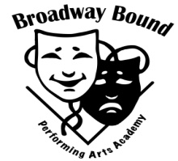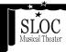
Audition Intensive
With Geoff Packard
From the Broadway shows:
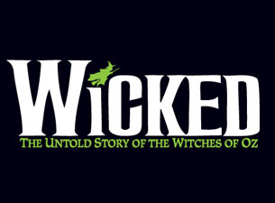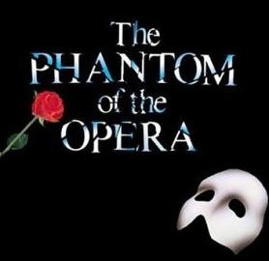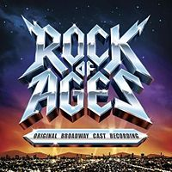
Saturday October 13th
12-3pm
@ Schenectady Light Opera
(427 Franklin St. Schenectady, NY)
$50
Open to students grades 9-12

An opportunity for students to work with a Broadway star! Get feedback on your own audition song, and learn some material from a show he has performed in ON BROADWAY!

Bring a 16 bar cut of an audition song, and be prepared to move.
Geoff Packard- Geoff has appeared all over this country and on the Broadway stages of The Phantom of The Opera (Raoul), Rock of Ages (Drew) and Wicked (Fiyero). He has won both Jefferson (Chicago area theaters) and Helen Hayes (Washington DC) Awards for his portrayal of the title character in Candide. Mr.Packard has also performed as a soloist with the Boston Pops, Detroit and Cincinnatti Symphony Orchestras, and just last year sang for the President of the United States!

Class is limited to 25 students To register: Broadway Bound Performing Arts Academy
email broadwayboundcamp@yahoo.com phone: (917) 447-6499

