Schenectady Civic Players
12 South Church Street, Schenectady, NY 12305

Open auditions for . . .

David Sedaris’ delightfully, humorous . . .
THE SANTALAND DIARIES
Directed by Duncan Morrison
-- Tuesday, September 15, and Thursday, September 17 –

(Role for one man, age 20s to 40s)

SCHENECTADY CIVIC PLAYERS -- Open auditions for “The Santaland Diaries,” by David Sedaris. Directed by Duncan Morrison. At Schenectady Civic Playhouse, 12 So. Church St., Schenectady. Tuesday, Sept. 17, and Thursday, Sept. 19, at 7:30 p.m. Sign-ups begin at 7:15 p.m. (Performance dates December 6 thru 15.) Role for one man, age 20s to 40s . More info from the director at email morrisonduncan@yahoo.com or 469-2269.

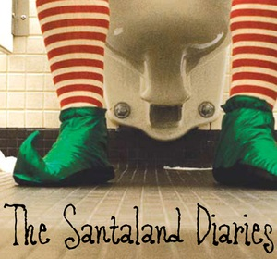 An unemployed actor decides to audition for the part of Crumpet the Elf at Macy’s during the holiday crunch. At first the job is only humiliating, but once thousands of children start pouring through Santa’s Workshop he becomes battle weary and bitter, entertaining us with stories of naughty children and pushy parents, empowered elves and sloshed Santas. “A delightfully thorny account of working as a Yuletide elf at Macy’s. Priceless observations, both outrageous and subtle. Destined to hold a place in the annals of American humor writing.” -The New York Times

For further information contact Duncan Morrison at morrisonduncan@yahoo.com or 518-469-2269

