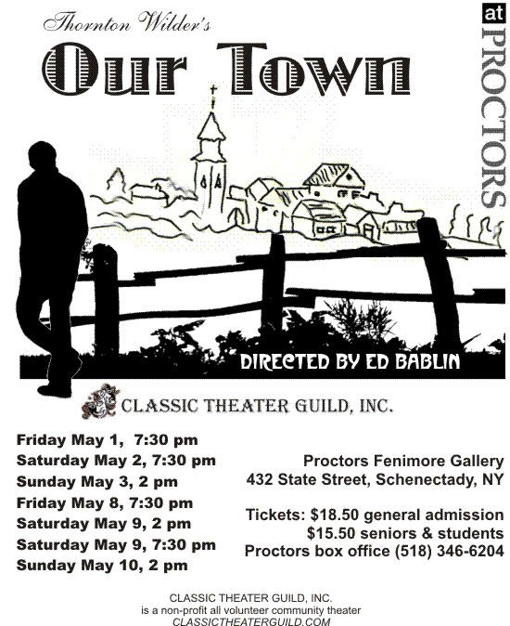

Classic theater Guild Is looking for an actor to be in our production of our town at proctors Theatre
in Schenectady New York the show dates are May 1,2,3,8,9,10th, any young men interested please contact the director Ed at 424-6579
Rehearsals will be starting in mid-March

