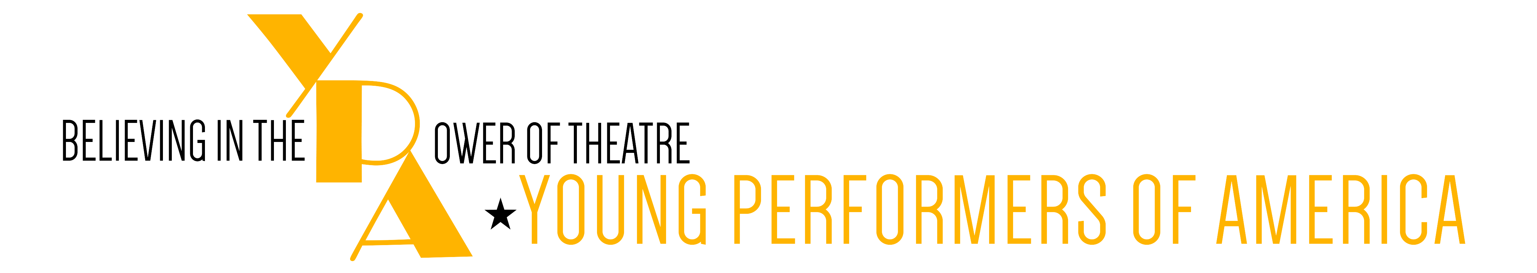

**Broadway Bound with YPA**

**Individual Registration Form**

**Macintosh HD:Users:dinaslawson:Desktop:YPASaratogaRegion-2.pdf**

*Two day conference to be held at the Ballston Spa High School:*

*March 4 and 5*

*Guest Artists Include:*

*Laura Osnes*

*Kara Lindsay  
Tommy Bracco  
Dell Howlett*

**Name of YPA Participant**: _______________________________________________

**Age**: _______

**Grade**: ______

**T-Shirt Size: _______**

**School/Organization you attend**: ______________________________________________________

**Home Street Address**: ______________________________________

______________________________________

_______________________________________

**Contact Phone Number**: ( )

**Email**: _________________________________________________________

**Please check fee payment below:**

Conference Fee: $195.00

**Please check payment option below:**

**_______** Payment by Credit Card:

Visa___MasterCard:___ #: _______ _______ _______ _______ Exp. Date:_____

Credit Card Holder’s Name: ___________________________________________ Sec. 3 digit #: _______

Amount Authorized to Charge: __________

**______** Check made payable to: Young Performers of America

**Registrations should be mailed to: Joe Shaver c/o Ballston Spa Middle School, 210 Ballston Avenue, Ballston Spa, NY 12020   
by February 26,2016**

**Macintosh HD:Users:dinaslawson:Desktop:YPASaratogaRegion-2.pdf**

PERFORMER CONSENT: I also understand that I am legally responsible to pay for the total number given above and absolutely no refunds will be provided by Young Performers of America. I further understand that an adjudicator cannot be guaranteed because of illness or professional conflict, but will be replaced with an adjudicator of likewise professional standing. I understand that YPA takes full responsibility to provide venue scheduled during the YPA Experience. I understand that any and all marketing to take place for said event must include the name and logo of Young Performers of America (YPA), and I accept the responsibility of reading and following all information communicated by Young Performers of America.  I understand that all communications with Young Performers of America (YPA) must be conducted through YPA National Educational Director and I cannot contact Broadway Adjudicators/Teaching Artists personally. I realize that the YPA creative team is continually performing and creating on a professional basis and their schedules are extremely demanding, therefore I accept full professional responsibility to answer all communications in a timely manner of 24-48 hours. I further accept all responsibility of any potential risk associated with those participating in an adjudication or master class, and affirm that I have and will take full responsibility for and provide proper health insurance of my participation protection.  I furthermore take full responsibility for emergency medical treatment if required and YPA has no legal responsibility for any event related injuries.  I hereby grant permission to be photographed by Young Performers of America for publicity and/or production purposes.

**PERFROMER SIGNATURE: _____________________________________DATE:** _______

**PARENT SIGNATURE: _________________________________________DATE: _______**