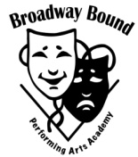
The Lion King

Broadway Master Class
Featured Instructor:
Class held at Broadway Bound Performing Arts Academy

Register now! This class will fill up!

Selena Moshell
Ensemble
Selena (Orlando, FL) is a Rollins College graduate (Environmental Studies) and has performed with the Pittsburgh CLO, Orlando City Ballet, Royal Caribbean, and Walt Disney World as a dancer and aerialist. Follow her adventures at www.selenamoshell.com - @selenamoshell
Saturday April 16th
Time: 10am-12pm Class Cost : $50

TO register: email- broadwayboundcamp@yahoo.com
Phone- (518) 728-4985

*As a part of this class, students will learn choreography to musical number from The Lion King!*

