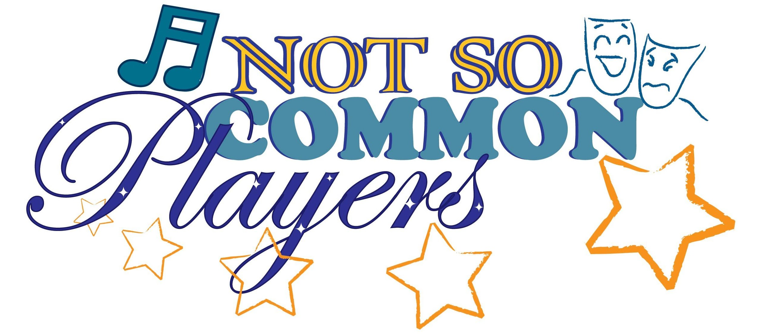
Dear Director Candidate:

We are very pleased that you are interested in directing at Not So Common Players! We are a unique community theater company located in Clifton Park, NY. For 15 years, we have provided quality entertainment for local audiences in a variety of spaces and formats. NSCP is generously funded by the Town of Clifton Park which provides us with wonderful opportunities as well as unique guidelines.

Part of our mission is to provide a variety opportunities for artists and audiences. In addition to performing shows from the standard musical theater repertoire, we have staged original shows and thematic revues. These are wonderful events for all involved. Additionally, our relationship with the Town of Clifton Park provides us with funds to offer small stipends to a select number of our production team members and provide our craft free of charge to our audiences.

The flip side of this relationship is that we try very hard to provide entertainment that is suitable for all audiences. We strive to select a variety of shows while maintaining certain standards and values. Foul language, nudity and explicit sexual or violent content is avoided. Please see the attached list of our previously performed shows to get a better idea of what is acceptable. Before any show is presented to the Board of Directors, the script will be read by members of the show selection team.

We have three different venues for our shows. Our summer show is always a large, well-known musical performed outdoors on the Clifton Park Common stage. Our spring and fall shows are typically smaller and may be performed either in the Clifton Park-Halfmoon Library or in the Little Theater of Shenedehowa High School East.

Please complete a Show Submission Form for each show you would like us to consider and attach a resume. Submissions are due by April 15th. We may request to interview director candidates. Submissions may be e-mailed to patodonnell@cliftonpark.org or mailed to PO Box 296, Clifton Park, NY 12065.

Thank you for your interest!

Not So Common Players

Not So Common Players Show History

Date Produced Show Type
2001 summer You’re Gonna Love Tomorrow musical revue
2002 summer Crazy for You musical
2002 fall Queen of Hearts original drama/musical
2003 summer South Pacific musical
2003 spring & fall Queen of Hearts original drama/musical
2003 New Year's Eve On Broadway/First Night Saratoga musical revue
2004 spring Rockin’ the Nite Away musical revue
2004 summer Annie Get Your Gun musical
2004 fall 27 Million original comedy/musical
2005 spring Some Enchanted Evening musical revue
2005 summer Guys and Dolls musical
2005 fall Little Shop of Horrors musical
2006 spring Two by Two musical
2006 summer Into the Woods musical
2006 fall National Icon original comedy/musical
2007 spring Little Mary Sunshine musical
2007 summer The Pajama Game musical
2007 fall Red, Hot & Cole musical
2008 spring They’re Playing Our Song musical
2008 spring Books on Broadway original staged reading
2008 summer Wizard of Oz musical
2008 fall The Spitfire Grill musical
2009 spring Godspell musical
2009 summer Bye Bye Birdie musical
2009 fall Clue, the Musical musical
2010 January 10th Anniversary Show musical revue
2010 spring The Fantasticks musical
2010 summer Once Upon a Mattress musical
2010 fall Working musical
2011 spring Anyone Can Whistle musical
2011 summer Cinderella musical
2011 summer Beauty and the Beast, Jr. musical NSCKids
2011 fall Zombie Prom musical
2012 January Vanities staged reading drama
2012 spring Jerry’s Girls musical revue
2012 summer Oliver! musical
Not So Common Players Show History (page 2)

Date Produced Show Type
2012 summer Annie, Jr. musical NSCKids
2012 fall Man of La Mancha musical
2013 January The Beast original drama
2013 spring Bingo, the Musical musical
2013 summer The Music Man musical
2013 summer Guys and Dolls, Jr. musical NSCKids
2013 fall The Secret Garden musical
2014 spring A, My Name Will Always Be Alice musical
2014 summer State Fair musical
2014 summer Oklahoma, Jr musical NSCKids
2014 Fall Have You Filled Your Bucket Today? NSCKids
2014 Fall Chess musical
2015 spring Little Women musical
2015 summer Anything Goes musical
2015 summer Little Mermaid, Jr musical NSCKids
2015 fall Violet musical
2016 spring Marvelous Wonderettes/Forever Plaid musicals/in rep
2016 summer Damn Yankees musical
2016 summer Suessical, Jr musical NSCKids
2016 fall Sweet Smell of Success musical

Not So Common Players Show Submission Form

Director Name

Show Name Authors/Composers

Synopsis

Musical Style Orchestra requirements

Check One:
Summer (Clifton Commons) _______

Fall/Spring (Library or Little Theater) _______

If Fall/Spring, is there a preferred or required time of year or venue (Little Theater or Library)?

Cast size:
1-10 _____ 11-20 _____ 21-30 _____ 31 + ______

Show Vision: Will this be a classic or alternative interpretation? If alternative, please explain

Potential Production Issues: (eg. Period costuming, complicated sets, special effects, etc.)

Potential Issues: (Foul language, sensitive topics, difficult casting requirements, etc.)

Production Staff that has been secured at this time: (Please only list those who have agreed)

If you are not selected as a Director, would you be willing to work as an Assistant Director?

