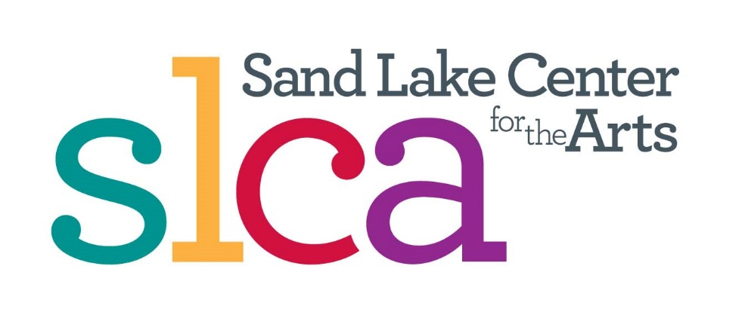
ONE ACT Play Festival
Looking for Playwrights Participation and Submissions

Sand Lake Center for the Arts
January 1 till May 1: Submission period for writers
All plays will be TANYS adjudicated, and monetary prizes of $100, $75 and $50 awarded to the three adjudicated as best written.
SUBMISSION REQUIREMENTS
Playwrights may submit a maximum of two plays. Plays may be submitted electronically to info@slca-ctp.org. Please include two attachments. One will be your cover letter which will include your contact information, the title and a brief synopsis of the play. The other attachment will be the play itself with NO contact information included except title. Please submit play(s) in Standard American Play Format. If you’re unfamiliar with this, there are many internet sites to help you. One would be https://pwcenter.org. If you are submitting a hard copy, you may send it to SLCA-CTP, PO Box 179, Averill Park, NY 12018. Again, please include a separate cover letter.
Plays should be able to be staged with MINIMAL SET. The Sand Lake Center for the Arts has a number of black boxes, and you might consider submitting a play that could be staged with only these. Any play with an elaborate set will be disqualified.
Plays should be able to be performed in 15 minutes or less.
AND, here’s the challenge. Plays must have some connection with the prompt “COLD”. It can be a theme, a characterization or simply a word-cold heart, cold day in hell, cold shoulder, cold war, someone suffering from a cold, a woman putting on cold cream-or you may have a play that just mentions, “It’s cold outside”. Be as creative and as clever as you want.
Contact producer, at kavanaughvsk@gmail.com if you have questions.

