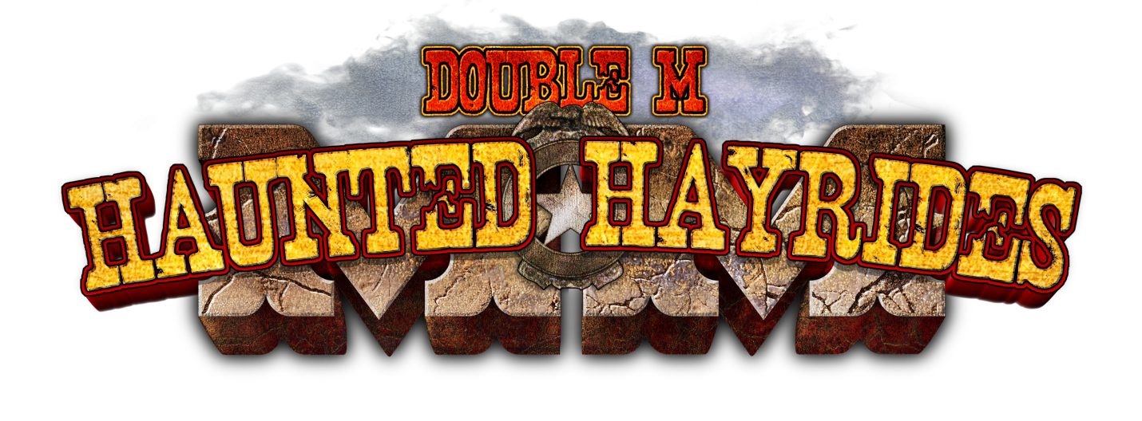
678 Route 67, Ballston Spa, NY
www.mmhauntedhayrides.com
The Capital Districts #1 Haunted Attraction for 29 Years!
Do you enjoy acting? Do you love Halloween and horror? How about scaring people? We want you!p
ustomer service.
Double M Haunted Hayrides will be hosting a job fair/casting call for new actors on August 28th and September 4th from 5 – 8 pm at the Double M (please attend one night). Please come with 2 forms of identification and be ready to fill out paperwork. We will be hiring on the spot!
You must be 16 years of age, we work late! No acting experience is necessary, but high energy and enthusiasm is a must! You must be available to work Thursday through Sunday evenings.
Pay starts at $11.25/per hour plus awesome employee incentives!
COME JOIN OUR SCREAM TEAM!

CONTACT INFO
Fill out an application before you come at: http://doublemhauntedhayrides.com/jobs/
Jennifer Martin – scareme@mmhauntedhayrides.com
518-884-9122

