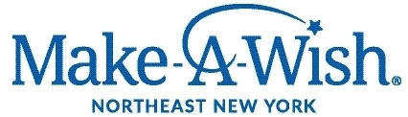

Audition Announcement

Actors needed for the role of Storyteller in ongoing walk-through experience called “Workshop of Wishes” for the Northeast New York
Chapter of the Make-A-Wish Foundation (aka Make-A-Wish Northeast New York).

The Storyteller role is a bard, tour guide, clown and friend. The Storyteller will be responsible for guiding wish kids, ranging in age from 4 to 17, through the scripted wish journey. Although there is a script, improvisational skills are a must!

Upon being cast as a Storyteller, actors will attend paid training sessions to create their own storyteller character and learn the scripted journey. Trainings will serve as rehearsals in order to prepare for the Workshop of Wishes events. Once activated as a Storyteller, actors will be scheduled as needed to introduce wish kids to the wish granting journey.

All genders, ethnicities, abilities and ages are encouraged to apply.
Actors must be located in Capital Region and have their own transportation.

To apply, please send photo and resume to:
Leigh Strimbeck at leigh.strimbeck@gmail.com

Paid position.

Start date: Training July or August 2021, events as booked after that

Position is ongoing.

