Starting January 3, 2022, Fort Salem Theater be offering classes in Ballet, Jazz, Jazz/Tap Combo, Acting Improv and both morning and evening fitness for participants of all ages and levels of experience. Classes will take place at the new Fort Salem Studio, located inside the historic Central House (224 S Main St, Salem, NY 12865). Enrollment is now open for all classes at www.FortSalem.com/Studio!
Monday | 5:30AM-6:30AM: Sunrise Strength & Fitness (Adult)
Monday | 4:00PM-5:00PM: Beginner Ballet (Pre-Teen)
Monday | 5:00PM-6:00PM: Beginner Ballet (Teen)
Monday | 6:00PM-7:00PM: Beginner Ballet (Adult)
Monday |7:00PM-9:00PM: Improv Comedy (Teen/Adult)
Wednesday | 4:00PM-5:00PM: Jazz 1 (Pre-Teen)
Wednesday | 5:00PM-6:00PM: Jazz/Tap Combo 1 (Ages 3-5)
Wednesday | 6:00PM-7:00PM: Jazz/Tap Combo 2 (Ages 6-10) – Almost Full!
Wednesday | 7:00PM-8:00PM: Cardio Party (Adult)
Saturday | 10:00AM-11:00AM Jazz 2 (Teen) (No Experience Necessary)

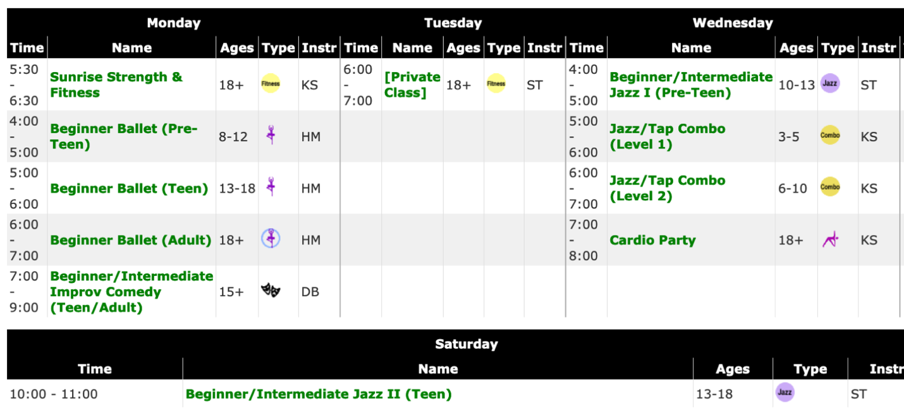
All dance and acting classes are invoiced in 8-week sessions at $96.
Sunrise Strength & Fitness and Cardio party are invoiced in 8-week sessions at $80.
An $35 enrollment fee is due at the time of registration (per family; waived for siblings)
Session One: Monday, January 3 - Saturday, March 5, 2021 (no class Feb 21-26 - school vacation week)
Session Two: Monday, March 7 - Saturday, May 7, 2021 (no class April 18-23 - school vacation week)
Session Three: Monday, May 9 - Saturday, July 7, 2021
An end-of-year performance will take place during Session 3 (June or July).
Please note: All classes include a 10-minute class transition time at the end of the allotted time slot.

