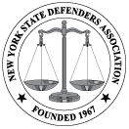

New York State Defenders Association
Public Defense Backup Center
Social justice organization seeking Black, Latino and white males who can play 25-30 for mock trial program, mid-June at Skidmore College, Saratoga.

Paid Work.

This job is for role players to help train Public Defenders.

The Role: Bobby Jones, the accused in an attempted murder case. Improvisation experience a plus but not required.
Training provided. For detailed info visit:

https://nysda.site-ym.com/page/BTSP_Actor_Info

Thanks!
Mark Dalton, Casting Director, NYSDA BTSP

