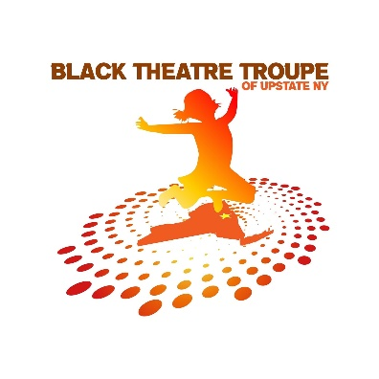

**Black Theatre Troupe of Upstate NY is holding auditions for**:

**HOODOO LOVE** by Katori Hall.

Auditions will be at First Congregational Church of Albany, NY located at 405 Quail Street.

Saturday February 18 at 11:00AM

No need to prepare anything ahead of time. Sides will be provided at the audition.

If you have any questions, please call 518-833-2621 or email [bttuny518@gmail.com](mailto:bttuny518@gmail.com)

Video auditions will be accepted if you cannot make the audition.

Email videos to: [BTTUNY518@gmail.com](mailto:BTTUNY518@gmail.com) by Friday February 17

Performances will be in the Lauren and Harold Iselin Studio at theREP  - located at 251 N Pearl Street in Albany, NY*eli*

June 1 – June 11, 2023

*June 1, 2, 3 and 4*

*June 8, 9, 10 and 11*

 Performance times are Thursday thru Saturday at 7:30pm and 4pm on Sundays*.*

HOODOO LOVE

A tale of love, magic, jealousy, and secrets. Toulou escapes from the Mississippi cotton fields in the 1930s to pursue her dream of singing the blues in Memphis. When she meets a rambling blues man, the notorious Ace of Spades, her dreams are realized in a way she could never have imagined. Written in vivid language that captures the blues, Hoodoo Love is a major debut.

*CAST OF CHARACTERS*

TOULOU – A young black woman who runs away from the cotton fields of Mississippi to the bluesy streets of Memphis. In Stature she is tiny, but her presence makes her seem taller than she is.

CANDYLADY – A former slave and the Hoodoo Madame of Beale Street with a timeless essence, yet with a quick tongue of a youngin’.

ACE OF SPADES – A young, sexy, ramblin’ bluesman with a “behind like a caboose” and hands that can play the blues out of any woman’s back.

JIB – Toulou’s older brother, a born-again Christian missionary

